CIEP Student Handbook
July 2022

3 UNI Culture & Intensive English Program
3 Mission
3 Goal
3 Accreditation
4 Affiliations
4 Administration & Faculty
4 CIEP Director
4 CIEP Student Employees
5 CIEP Student Services
Coordinator
5 Instructors
5 Graduate Students
5 Sessions
5 Admissions Process
5 Placement of New Students
6 In-person Placement
6 Online Placement
7 Re-Evaluation of Students
8 CIEP Academics
8 Class Information
9 Class Sizes & Offerings
9 Lab
9 Class Cancellations
9 American Classroom Guidelines
10 Electronic Devices
11 Teacher & Student Relationships
11 Cheating
12 Plagiarism
12 Attendance
13 Homework
13 Syllabus & Textbooks
13 Class Exams
14 Student Learning Outcomes
14 Grades
17 CIEP & University Policies
17 Academic Probation
17 Low Attendance
17 Repeating Poor Performance
18 Part-Time Students
18 Make Up Policy
18 Dismissal
18 Withdrawing from CIEP
Contents
18 Academic Credit
18 Refunds
19 Transferring Schools
19 Changing Levels
20 Late Arrival Policy
20 Re-Enrollment & Placement
20 Student Records & Privacy
20 Code of Conduct
22 Zero Tolerance Policy
22 Activities Policy
22 Conduct & Safety
23 University Bills (U-Bill)
23 Paying Your U-Bill
24 Due Dates
24 Late Fees
25 Account Holds
25 Standard English Tests
25 TOEFL
25 IBT
25 Student Problems/Concerns/
Grievances
26 CIEP Class Evaluation
27 CIEP & Government Policies
27 VISA & Immigration Status
27 F-1 Visa
27 Maintaining F-1 Status
28 J-1 Visa
28 Maintaining J-1 Status
28 Absences
29 On Campus Jobs
29 Taxes
30 Vacation from Studies
32 University of Northern Iowa
32 Transitioning into Academic
Classes
32 Conditional vs. Direct Admission
Procedures
32 Conditionally Admitted
Students
32 Directly Admitted Students
33 Academic Advising
33 Office of International
Admissions
33 Majors & Minors at UNI

33 About UNI
33 Office of International Engagement
33 International Student Organizations
34 Mail
34 Changing Your Student Information
34 Student Resources
34 Academic Learning Center
35 Wellness & Recreation Center (WRC)
35 Rod Library
35 Computer Labs
36 Student Accessibility Services
36 Public Safety
36 Parking Permits
36 Housing
36 Interim Housing
36 Dining & Meal Plans
37 Laundry
37 Living off Campus
37 Health
37 Required Immunizations & Vaccinations
38 Health Insurance
38 Medical Services
39 Weekend Medical Services
39 Emergency Resources
40 Emergency Procedures
40 Building Evacuation
40 Threatening Person/Armed Intruder
40 Fire
40 Tornado Warning
40 Shelter-In -Place
41 Suspicious Object
42 Culture & Community
42 Culture Shock
43 American Cultural Habits
43 Greetings
43 Names & Titles
43 Unspoken Language
43 Social Equity
43 Drink
44 Time
44 Cleanliness
44 Smoking
44 Space/Privacy
44 Friendship

44 Social Invitations
45 Shopping in the US
45 Supermarkets
45 Drug Stores/Pharmacies
45 Discount/Department Stores
45 Thrift Shops
46 Garage Sales
46 Coupons
46 Tipping
46 Holidays
47 Online Safety Tips
47 Temperature & Weight Conversions
47 CIEP Graduation
48 Community Colleges
48 Trouble with the Law
48 Consular Notification
48 Social Security
49 Record Requirements
49 UNI Student ID
49 Age Verification
49 International Student
49 Cedar Falls
50 Weather
50 Religious Institutions
51 Travel/Transportation
51 Automobiles
51 Buses
51 Planes
51 Banking
52 Cell Phone Options

Appendixes
A-1 Campus Map
A-2 English Placement Test Results
A-3 Formal Student Grievance
Form
A-4 Student Requests & Concerns
Form
B-1 UNI CIEP Proficiency Scale
B-2 Guidelines for In-Class Behavior
& Academic Integrity
B-3 Notice of Plagiarism & Cheating
B-4 Notice of Academic Probation
B-5 Final Grade Report
B-6 CIEP Grading Scale
C-1 SEVIS Transfer-In Form
C-2 Release of Information
C-3 UNI CIEP Class - Teacher
Evaluation Form
D-1 Notification of Absence Form

UNI Culture and Intensive English Program
MISSION
The primary mission of the Culture and Intensive English Program (CIEP) is to provide English language learners with high quality, intensive English instruction, as well as academic cultural orientation in preparation for study at the University of Northern Iowa or other institution of higher learning.

Through its many programs, events, and connections on and off-campus, the UNI CIEP seeks to accomplish the following:

- Teach English for Academic Purposes in the Intensive English Program in preparation for enrollment in academic programs at UNI.
- Collaborate with different academic programs at UNI to co-teach specialized sections and workshops for international and multilingual students to support their academic success in university classes.
- Support the UNI vision to promote diversity, equity and inclusion on campus and the community.
- Provide students with the cultural knowledge and awareness which they will need to function well both academically and socially.
- Inform students about options and opportunities for academic study at UNI and encourage them to apply for admission.
- Recruit students internationally and domestically for participation in English language programs in order to develop cross-cultural and educational opportunities on the UNI campus.
- Serve as a resource for faculty, staff and students in English language instruction and cross-cultural orientation at UNI.
- Provide support to local school systems in preparing their English as a Second Language students for university study at UNI or other institutions of higher education.

GOAL
The primary goal of the CIEP is to improve our students’ ability to communicate in English. We strive to improve specific skills in grammar, writing, listening, speaking, and reading. The CIEP does this by teaching students the skills and strategies that will help them use English both academically and socially. Additionally, there are many opportunities for students to practice these skills outside of the classroom with roommates, conversation partners, other university students, and community members.
Another important part of the CIEP is learning about American academic culture and popular culture. We closely relate English language instruction with American cultural experiences because you cannot use a language well if you do not understand the society and culture in which it is used. It is also difficult to study and work in the United States if you are not proficient in the English language. The CIEP works very closely with students to find the best opportunities for them to learn about the English language and American culture.

ACCREDITATION
The CIEP is accredited by the Commission on English Language Program Accreditation (CEA) under the authority of the U.S. Department of Education in Washington, D.C. The CEA regularly reviews and regulates standards for intensive English programs wishing to be accredited. The CEA is the only officially recognized accrediting body in the United States and programs achieving accreditation status must undergo a rigorous process which includes a site visit, self-study report, and subsequent updates and reports after initial accreditation.

AFFILIATIONS
The Culture and Intensive English Program is a member of the following professional organizations:
- UCIEP: Consortium of University and College
- AAIEP: American Association of Intensive English Programs

ADMINISTRATION & FACULTY
The CIEP has both office and teaching personnel on its staff.

CIEP Director: The CIEP Director plans class schedules, supervises the staff, answers students’ questions regarding the CIEP, and makes sure that the program follows its policies. The Director’s office is located in Bartlett Hall, Room 3023 (see Appendix A-1 for a campus map). You are encouraged to set up an appointment to talk to the CIEP Director if you have questions such as:

- What should I do if I have a family emergency and have to miss several classes?
- Even though I’ve talked to my instructor, can you help with academic or personal problems?
- What can I do if I do not understand my teacher?
- What can I do if I have a problem with a classmate?
In addition to the director, there are staff members who work to make the CIEP run smoothly. These staff members also work in Bartlett Hall, and can be contacted by telephone at 319-273-2812 or by email at ciep@uni.edu. The following CIEP Office staff is happy to respond to any questions you may have about the CIEP.
CIEP Student Employees: There are several UNI students who assist every day in the CIEP Office. The office staff will be the first people you meet when entering the main office. Our office staff helps you first or decides who can best help you. Please contact the CIEP Office staff if you have questions such as:

- Where do I pay my tuition?
- When can I pick up my class schedule?
- How can I get copies of my grades?
- Where is the classroom located?
- Why is my U-bill charged for this amount?
- How can I be reimbursed for a class that I dropped?
- How do I apply to the CIEP?
- Are there scholarships available?
- Which documents are needed for the application?
- My I-20 will expire next month. What should I do to keep my immigration status active?

- What should I do if I want to travel outside the U.S. during my summer break?
- How can I apply for admission to UNI or, if conditionally admitted, start academic classes?
- How can I enroll my friends or family member into a CIEP class?
- When is the next TOEFL test?
- Can I have a letter for my sponsor?
- Where can I pay my tuition?

CIEP Student Services Coordinator: This person organizes social, cultural and educational activities for the CIEP, administers evaluations and is responsible for the Conversation Partner and the CIEP International Friendship Programs. Please contact the Activities Coordinator if you have questions such as:
    - How do I sign up for a conversation partner?
    - Who can participate in the field trips?
    - Where should I go for the culture talk?
    - I’m not sure what to do. Can you give me advice?
    - I want to work on campus. How do I get a job?
    - Where can I sign up for a CIEP activity?
Instructors: In addition to the office staff, the CIEP also has instructors who deliver English Language instruction focusing on skills such as reading, writing, grammar and listening/speaking skills. These instructors have Master’s degrees in TESOL (Teaching English to Speakers of Other Languages) and many years of experience in teaching English in the United States and overseas.

All CIEP instructors have regular office hours each week so that you can meet with your instructors for additional help or to discuss individual course problems. It is best if you learn when your instructors have their office hours and use this time for assistance and review.

Graduate Students: Additionally, the CIEP may employ 1-2 graduate students each year. These students may instruct in the CIEP while completing their Master’s degree in Teaching English to Speakers of Other Languages (M.A./TESOL). In many cases, they have previous teaching experience and have lived or worked in the United States or in other countries.

Learn more about the CIEP staff: https://ciep.uni.edu/staff

SESSIONS
The CIEP offers 5 full sessions per year: 2 in the fall semester, 2 in the spring semester, and 1 in the summer. Each session lasts eight weeks and includes 20 hours of class work per week including 1-hour lab time.

ADMISSIONS PROCESS
All applications for admission into the UNI Culture and Intensive English Program must be completed and returned to the CIEP at least 2 months prior to the starting date of classes. To be eligible for the UNI CIEP, students must be at least 18 years of age and fulfill all requirements for their visa status. To be admitted, students must submit a completed application form, financial guarantee, application fee and a copy of their passport. Students are also expected to have the following skills before enrolling in our courses: Fluently read and write in a first or native language, understand 1 to 2 sentences in speaking, read and understand 1 to 3 paragraphs in English with present, past, and future verbs, write 4 to 8 sentences about a topic, write sentences with be (is, am, are) and have and has, write with simple past of be (was, were) and regular verbs (-ed).

PLACEMENT OF NEW STUDENTS
At the beginning of each session, the CIEP tests all new students entering the program and academic students provisionally admitted for academic study at the University. The instructors will review the results from the test and you will later receive your class placement. There are two methods for the administration of placement exams: online and in-person. The exam you are given will be based on availability and other circumstances decided by the CIEP.

In-person Placement:
The in-person placement exam has five parts:

- Written Essay: You will be given 45 minutes to write about a general topic such as comparing city life to country life or describing the ways you can learn a new language. You will not be able to use or have a dictionary, cell phone or other electronic device.
- Reading Test: You will have 50 minutes to read several small passages and select the correct answer on a multiple-choice test.
- Listening & Note-taking Test: You will listen once to a short conversation and a taped lecture about a general topic that is important to students studying in a foreign country. There will be questions about the conversation and lecture. For the lecture, you will take notes and can use these notes as you answer questions. The exam is 45 minutes long.
- Grammar Test: You will have 30 minutes to answer multiple-choice questions that increase in difficulty and complexity.
- Interview: In the interview, two instructors will ask you questions about yourself and other general topics. The interview is approximately 5-7 minutes long.

A sample rubric used to score the placement exam is found in Appendix A-2.

Online Placement:
The online placement exam will be administered via Zoom. Links to the individual parts of the exam will be provided in the Zoom chat box the day of the exam. Cameras and audio MUST be turned on and working the day of the exam. The online placement has 6 parts:

- Interview: For the interview, you will join a breakout session in the Zoom meet with two CIEP instructors who will ask you questions about yourself and other general topics. The interview is approximately 5-7 minutes long.
- Listening Test: You will have 20 minutes to listen to an audio recording and answer questions.
- Grammar Test: You will have 20 minutes to answer multiple-choice questions that increase in difficulty and complexity.
- Reading Test: You will have 30 minutes to read a small passage and select the correct answer on a multiple-choice test.
- Reading & Writing Test: You will have 30 minutes to read the same passage and write responses to written prompts.
- Written Essay: You will be given 30 minutes to type an essay on a general topic such as comparing city life to country life or describing the ways you can learn a new language. You will not be able to use or have a dictionary, cell phone, or other electronic device.

RE-EVALUATION OF PLACEMENT
As a new student, instructors evaluate you to see if you are placed in the correct classes. If you believe the class is not an appropriate placement, you are encouraged to complete the Student Requests and Concerns Form (Appendix A-4). Every term, all CIEP teaching staff members meet after the first week of classes to discuss the placement of all new students. If the staff agrees that a new student is not placed correctly, they will recommend a change in level.

CIEP Academics

CLASS INFORMATION
After you complete the initial placement test, you receive a class schedule with a list of your classes, instructors' names, times and room locations. The instructors will meet you in the classroom at the beginning of each class.
As a full-time CIEP student, you receive 3-hours of daily classroom work (Monday through Friday) as well as attend a 1-hour lab in one of 5 levels of instruction:

CIEP I: Beginner - High Beginner
CIEP II: Low Intermediate
CIEP III: Intermediate
CIEP IV: High Intermediate
CIEP V: Advanced
You are expected to attend all classes daily, use English at all times in those classes, and complete homework assignments. CIEP instructors will do a combination of pair/partner work, group work, individual projects and instructor presentations to teach English. You will not spend most of your class time listening to your instructors talk. Instead, you should be active in answering questions and doing activities in the classroom.
The CIEP curriculum is designed to meet the needs of our students, yet flexible enough to allow teachers to make use of their individual strengths in teaching. The classes are student-centered and use the latest methods in the field of teaching English as a Second Language (ESL). This means that you will be asked to participate in activities and perform work that is new and unique to you. Please have an open mind and take advantage of the opportunities to learn and practice English in class and outside of class.
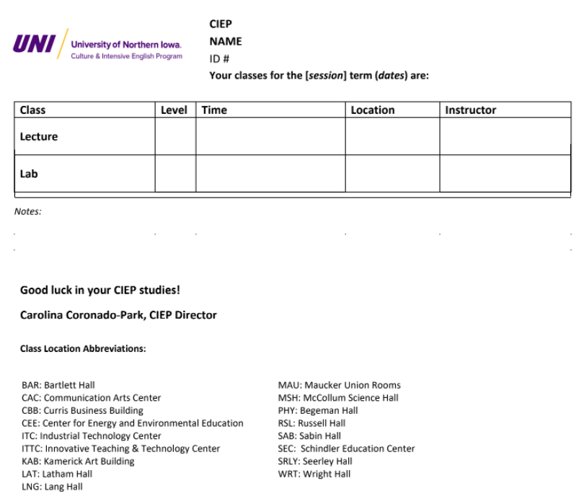
CIEP classes (including lab) meet 20 hours a week, for 4 hours a day, Monday through Friday during the 8-week session. There is a 10-minute break each hour. Please see the example of a CIEP Student Class Schedule:

Class Sizes & Offerings
Based on enrollment, not every level will be offered each session. If a level is not available, the CIEP Director will offer an alternative or the level will be available in the next CIEP session. The average class size at the CIEP is 12 students and the CIEP tries to limit its class size to 16 students. Classes with more than 16 students will be considered for a second section.

Independent Study: In special circumstances (such as uncontrollable absences or classes not being offered), the CIEP Director can arrange for you to do an independent study with a teacher. You could meet with the teacher alone on a weekly basis to discuss your progress as you study to complete the material. Independent study work is graded and recorded in the CIEP office and the University. The price of an independent study is the same as one class.

Lab
Students must attend the CIEP lab for one hour each day. This is a required period for students to gain extra help with assignments, take extended tests or quizzes, work on assignments, and engage in cultural activities. Students must bring their textbooks and other class materials to lab. Lab classes are conducted from the first day of CIEP classes until the days of final exams; CIEP labs are not conducted on the last two days of the session on final exam days. The lab instructor is a different teacher, not the classroom teacher.

Class Cancellations
In certain instances, the University will cancel or postpone classes or other events. The University posts all weather and security related alerts on their website at http://www.uni.edu/. If a CIEP class has to be cancelled due to weather, an instructor’s illness or some other reason, the CIEP will attempt to reschedule the class.

American Classroom Guidelines
You may find American teaching methods and practices quite different from those you are familiar with at home. Regular class attendance, preparation for regular examinations throughout the term and participation in class discussions are all expected in the American educational system. You are expected to:
  - Come to class on time.
  - Take notes in class.
  - Pay attention and do not sleep in class.
  - Have a positive attitude, make your best effort.
  - Bring a pen, pencil, notebooks, and textbooks.
  - Participate in class.
  - Respect your fellow students and your instructors at all times; do not use offensive language, be disruptive, or refuse to cooperate with your instructors and classmates.
  - Complete your homework by the due date.
  - Use English inside the office and classroom buildings at UNI.
  - CIEP classes are English-only classes; do not use your native language.
  - Keep your classroom clean. Do not leave paper, empty containers, bags, or other waste inside or outside of the buildings.
  - UNI campus is smoke-free; do not smoke inside of the campus buildings or outside on campus.
Notify your instructors and the CIEP Office when you are absent. If it is because of an illness, go to the UNI Student Health Clinic for treatment. You can present a notice or letter from a medical provider (doctor, nurse, etc.) if you were absent due to illness/hospitalization for three or more days, and your absences may be excused.

Classroom Participation: Class participation is also very important. Your instructors will give you many opportunities to speak and write during class time. CIEP classes are English-only, meaning that only English may be spoken in your classes. Also refrain from speaking your native language in the CIEP office and during CIEP activities. This will help you to learn English faster and more efficiently.
Practice your English as much as possible, both in class and outside of class. Use your English-language skills at every opportunity.
In general, professors welcome questions from students and encourage student participation in class discussions. In many classes, the professor expects discussion and questions from students. Be ready to share information (culture, economics, politics, religion, etc.) about your country in class because many people are interested in learning about other cultures. It is also a very good topic for your future presentations.
Never hesitate to ask a question about something you do not understand. A good time to ask these questions can be during a class discussion, before or after class, or during a professor’s office hours. Professors also keep regular office hours and usually announce them during the first or second class.

Behavior & Academic Integrity: If your behavior in your CIEP class is not appropriate, your teacher(s) will tell you. They will also explain what appropriate behavior in an American university classroom is. Their explanation is not meant to embarrass you, but to guide you so that you are more productive.

Behaviors that are not appropriate or acceptable in the classroom include:
  - Coming to class late and disturbing the teacher as you enter.
  - Never having homework done or ready.
  - Not being respectful to your teacher or classmates.
  - Talking to classmates while the teacher is instructing class.
  - Using a cell phone or other personal communication device when not appropriate or allowed.
  - Speaking to others in a language that is not English.
  - Asking so many questions that the teacher has no time to teach or to take others’ questions.
  - Not wanting to join in group or pair work activities.
  - Leaving the class early in a loud manner by packing books and speaking to others.
  - Leaving and returning to the classroom often during the hour.

If you continue behaving in an unproductive or inappropriate way, you may be asked to meet with your teacher or the CIEP Director. Together you will review your behavior in class and suggest appropriate behavior. A form called Guidelines for In-Class Behavior & Academic Integrity (Appendix B-2) is used in the meeting. Afterwards, you will be asked to sign the guidelines and given a copy (the original stays with the CIEP). This is a record of what was discussed in the meeting. If the unproductive or inappropriate behavior continues, the matter may be referred to the Dean of Students and/or you may be dismissed from the CIEP class or program.

Electronic Devices
It is the policy of the CIEP not to allow the use of personal electronic devices during exams and other testing situations without the permission of the teacher. Personal electronic devices include but are not limited to: electronic dictionaries, computers, cell phones, or communication devices other than cell phones. If you use an electronic device during an exam without the permission of the teacher, this is considered an act of cheating and you are subject to the same penalties as described in the cheating policy.
It is also the responsibility of the CIEP to instruct you on how to use non-electronic means of support for essay type exams that allow for support from texts such as a grammar or reference dictionary. The teachers in CIEP will instruct you on how to use these non-electronic means of support throughout the program.

Teacher & Student Relationships
The teacher-student relationship within the classroom regarding classwork or academics is confidential. Disclosures of a student's personal or political beliefs expressed in connection with course work may not be made public without the explicitly granted permission of the student. However, personal information shared with an instructor that may indicate the need for immediate intervention may fall within mandatory reporting laws. Please see the following regarding the University’s policy on mandatory reporting: General Policy 13.02

International students often find the classroom atmosphere and the student-professor relationship very casual and informal in American universities. Even though it is a casual and informal relationship, the teacher is not your friend. The goal of the teacher is to help you learn and improve your English and assist you with questions that you have about your classes.

Cheating
Presenting someone else’s work as your own in a testing situation or exam is an act of cheating. Cheating is also an act of academic dishonesty and is a serious offense in the U.S. academic environment. The CIEP adheres to the same academic standards as the University of Northern Iowa found in the UNI’s Policies and Procedures Manual (https://policies.uni.edu/301).
“Students at the University of Northern Iowa are required to observe the commonly accepted standards of academic dishonesty and integrity…Cheating of any kind on examinations and/or plagiarism of papers or projects is strictly prohibited.”
We also know that cheating and the consequences for cheating are not universal throughout the world. Therefore, the CIEP makes efforts to instruct students about cheating and the CIEP’s policies about cheating. Teachers discuss cheating in class and should warn you about the penalties for cheating. If you are found to be cheating, you will be penalized depending on the type of offense and receive a Notice of Plagiarism & Cheating (see Appendix B-3). A copy is kept in your permanent file, too. Also, cheating offenses discovered after an exam subject you to disciplinary action as well.
Minor cheating offenses can result in a warning and/or a meeting with the teacher. Examples include:
  - Glancing at neighbor’s paper during an exam.
  - Whispering to neighbors during an exam.
  - Making hand signals to others during an exam.

More serious offenses can result in a failing grade for the exam. The teacher/proctor will ask you to pass in your paper and inform you that the exam will not be graded because of cheating. Examples include:
  - Using textbooks, notes, papers during an exam.
  - Using an electronic device during an exam.
  - Leaving the room to get the help of others during an exam.
  - Using any non-exam materials (paper, electronic, or other) during an exam.
  - Distracting the teacher or proctor to help others cheat during an exam.

Very serious offenses can result in a failing grade for the class or expulsion from the CIEP. Examples include (but are not limited to):
  - Sharing exam contents with others.
  - Copying or recording exam materials for others.

Plagiarism
Plagiarism is presenting someone else’s work as your own. Any ideas or materials taken from another source (student, website, book, friend, etc.) for either written or oral use and presented by you for evaluation purposes must be acknowledged and cited.
Anytime you do not cite a source, your teacher will assume that the words written are your original ideas. When using ideas or words from other sources to complete an assignment, you must cite where you found them. Your teacher will help you learn the correct way to cite and credit sources, but you can ask for help, too. Examples of plagiarism include:
  - Copying words, phrases, sections of another student’s paper and presenting it as your own.
  - Cutting and pasting material from an internet source onto your own work and presenting it as your own.
  - Asking friends to help you edit and/or write papers and presenting the paper as your own.
  - Purchasing an essay or research product and presenting it as your own.
  - Submitting the same work/product/paper to more than one teacher to fulfill more than one assignment is also an act of plagiarism if the teachers are not aware of your action.
Please note that plagiarism is an act of academic dishonesty and a serious offense in the U.S. academic environment. Penalties for plagiarism can be severe. If you are found to commit plagiarism, you will be penalized depending on the circumstances. Please refer to Notice of Plagiarism & Cheating (Appendix B-3) for examples of plagiarism and penalties.

Using artificial intelligence to develop and write work for you is also considered a form of plagiarism. The work developed will not show your English proficiency or your critical thinking skills. Therefore, work done through artificial intelligence will not be accepted.

Attendance
Regularly going to class is not only important for learning a new language but it is also necessary to keep your immigration record in good status. United States immigration rules for F-1 students require you to attend classes regularly and full-time. Regular attendance in the CIEP is having 100% attendance in your class and lab time. Attendance is mandatory for both class and lab. However, we understand that there are situations when a student cannot come to class. In the CIEP, if you attend less than 80% of classes and lab time, you get a warning. In other words, you are missing 22 hours or more of a 3-hour lecture class, 15 hours of a 2-hour lecture class, and/or 7 hours or more of lab class. If this happens again in the next term, you are put on probation. (See appendix B-4 for Notice of Academic Probation).

Hybrid Classes: CIEP classes may be hybrid – this means that there may be a face-to-face and online component for the same course. During Zoom meetings for lectures and labs, attendance will be taken every hour. Students are counted “present” if you have your camera on and are participating in class. If students do not turn your cameras on or participate in class, you are counted “absent” for the hour.

Homework
Homework is serious work and it is a very important part of your English study. It provides you with the opportunity to think about the topics that you study in class. Do your homework carefully and on time. During most weeks, you can expect to spend the following amount of time on homework**:

 | Levels I and II | Levels III and IV | Level V
Writing | 4-5 hours | 5-6 hours | 8-9 hours
Listening/Speaking | 3-4 hours | 3-4 hours | 4-5 hours
Reading | 4-5 hours | 5-6 hours | 7-8 hours
Total | 11-14 hours | 13-16 hours | 18-21 hours

**Extra time may be required for logs and journals.

Syllabus & Textbooks
During the first week of classes, your instructors will give you a class syllabus (plan) explaining the requirements for the class and how he or she will grade your work. Once the instructor makes the final class/level grade, it cannot be changed. You need a C grade or higher in the class in order to pass.

Bring all of your textbooks and/or packets to class every day, along with your other school supplies. Your instructors will tell you which textbooks to buy from University Book and Supply on 23rd Street. The CIEP website also lists the textbooks needed for each class at https://ciep.uni.edu/levels. You should not share textbooks with other students. You cannot re-use old textbooks with marked and completed pages.
If you wish to return a newly-purchased textbook to the bookstore, please save your receipt to show the store clerk. University Book and Supply will only accept returns during the first two weeks of the semester. After that, you will not get any money back for your book until the end of the semester during book buy-back hours.

Class Exams
Diagnostics: At the beginning of the term, you will take an exam in class to determine how much you know about different aspects of English. This exam can also help determine if you have been placed in the correct level or not. A diagnostic exam is not a part of your course grade.

Instructors will give you tests and quizzes as a way to see how much you have learned, understand your English skill level, and decide what you need to know. Instructors will also give you projects, oral reports, written essays and other assignments to improve your skills and to evaluate your progress. You are expected to complete and turn in all assignments given to you by the instructor. Failure to do so may result in a lower final grade.
Take all tests and quizzes on time. If you are absent, be sure to contact your instructor as soon as possible for a chance to take the test at a separate time. The instructor will decide whether or not you may take the test.

Finals: Final exams are given during the last week of the 8-week term. Exams are not given before or after this time unless you have an emergency. If you miss final exams, it will affect your final grade for the class. Therefore, you need to check the CIEP calendar before making your travel plans. After you take finals, you will be able to see your class grade in your Student Center in MyUniverse two weeks later or when you pick up your new class schedule (see Appendix B-5 Final Grade Report).

Student Learning Outcomes
For a detailed description of CIEP Student learning outcomes, visit https://ciep.uni.edu/sites/default/files/u6/ciep_course_goals_objectives_slos.pdf

Grades
Grading scale: The CIEP uses the same grading system as the University of Northern Iowa. You can earn grades from an A to an F. You must receive a C or above to pass your class. If you receive a C- or lower, you must repeat that same level for the next session (see below or Appendix B-6 for the UNI CIEP Grading Scales).

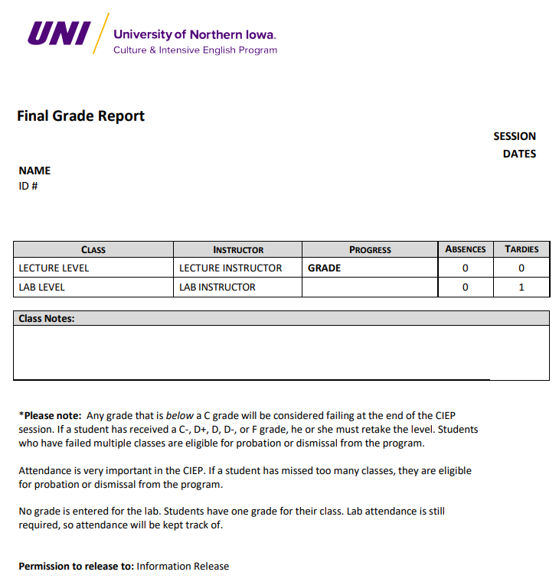
Grade Reporting: Students will receive an official grade report halfway through the term (midterm) and again at the end of the term (final). You can show this report to anyone you want to see it. However, the CIEP can only share the results with others if you sign an information release document. For questions about midterm or final grades, please ask the CIEP office.
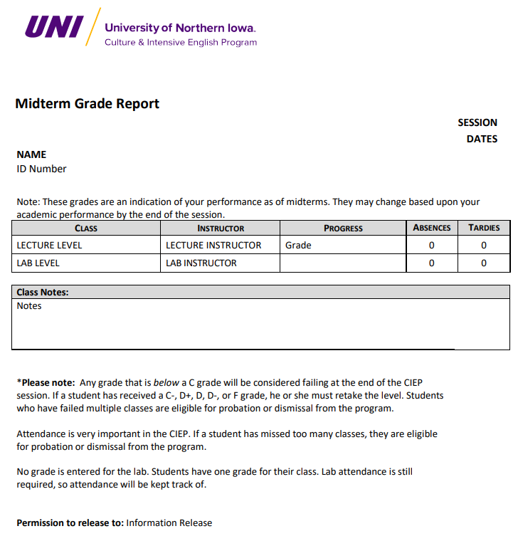
MyUniverse Grades: You may view your grades in MyUNIverse two weeks after final exams. To view your grades, log into MyUNIverse using your CatID. Click on the “Go to my Student Center” link on the “My Page” tab. In the Academics section, select “Grades” in the drop-down list. Click the Go button. Your “View My Grades” page should appear.

Grade Appeals: If you feel that a final grade is inaccurate, you must first meet with your instructor and notify the CIEP Director, in writing, before the first day of classes for the next session. To notify the director, you must complete a Formal Student Grievance Form (see Appendix A-3) and include the reason(s) for wanting a change in grade and submit it to the CIEP Director. The CIEP Director will notify you of a decision within ten days of receiving the form.

No Grade/Incomplete: Usually, you receive grades for your classes in the CIEP. However, if you begin the class late, midway through the session, or you do not wish to receive a grade, you will be given an incomplete (Inc) for the class. In these situations, you are required to repeat the class for the full session in order to receive a grade and pass to the next level.

Failing: If you fail a CIEP course, you should first talk to your instructors to find out how to improve and get extra help. You and your instructor may make a step-by step plan for passing the course. It is the duty of the student to ask for extra help from instructors or CIEP staff.
If you request and need additional help, the CIEP instructors and staff can find various services on- campus to assist you such as the speech and hearing clinic and the counseling center.

CIEP & University Policies

ACADEMIC PROBATION
The CIEP hopes that you make good progress in your classes. However, if you do not make good academic progress, you will receive an academic warning. If you are not successful in improving your academic progress, you will be placed on academic probation. Academic probation is a time when your academic progress and success are supervised by the CIEP Director. During this time, it is important to improve your grades and/or attendance by going to all classes, seeking help from your teachers outside of class, maintaining a positive attitude in class and completing all assignments.
If you do not successfully leave academic probation, you will be eligible for dismissal from the CIEP. There are two reasons you are put on academic probation: 1.) Low Attendance and 2.) Poor Performance (repeating the same level/class). In all cases, you will receive a Notice of Academic Probation (see Appendix B-4).
If you have any questions about your academic progress or probation, you may ask the CIEP Office staff. If you feel you need more help in your classes to understand the material, you are encouraged to seek help from your teachers outside of class during their office hours, attend all of your classes, maintain a positive attitude in class and complete all of your homework.

Low Attendance
It is important to go to all of your classes. Regularly going to class is not only important for learning a new language, but it is also necessary to keep your immigration record in good status. United States immigration rules for F-1 students require you to attend all classes.

Regular attendance in the CIEP is having 100% attendance in your class and lab time. Attendance is mandatory for both class and lab. In the CIEP, if you attend less than 80% of classes and lab time, you will be put on probation. In other words, you are missing 22 hours or more of your lecture class, and/or 7 hours or more of your lab class.

Once on probation, you must maintain at least 80% attendance. If you maintain 80% attendance in all aspects for the next session, you are removed from probation; otherwise, you are no longer enrolled in the CIEP. If you return to probation in later sessions for lack of attendance, you must maintain 80% attendance in all classes for the remainder of your study in the CIEP or be dismissed from the program (missing 22 or more hours from class, and/or 7 or more hours from lab).

Repeating Poor Performance
In some cases, you may not pass a class. The CIEP realizes that not all students learn English at the same pace and their abilities to learn English as a non-native speaker may differ, too. However, the CIEP also realizes that repeating a class several times signals that you are unable to cope with the material for the class and for the program in general. Therefore, if you are unable to pass a course for a second time, you will be put on academic probation and asked to meet with the director. If you are not able to pass the class in the next 8-week session, you will no longer be enrolled in the program.
Full-time CIEP students can remain on probation status for poor performance for only two 8-week sessions (consecutive or non-consecutive) during their entire time of full-time study in the CIEP.

PART-TIME STUDENTS
Due to the new integrated skills model, discrete skills are not taught at particular times during the day or week. As a result, it is not possible to take “just a writing class,” for example. Therefore, it is not possible to accommodate part-time students in CIEP classes. However, for those who may not be able to attend Lab class, the issue is managed on a case-by-case basis.

MAKE-UP POLICY
The CIEP is an intensive English language program and it is important that you keep up in your studies and be prepared. Therefore, it is your responsibility to complete tests, quizzes, and other evaluations on the day they are administered. It is your responsibility to turn in homework and projects on the day they are due.
If you are absent, you are still responsible for the material covered in class. In addition, your teacher is neither obligated nor responsible to provide you a make-up test/quiz or accept and grade late homework. It is the teacher who decides the makeup policy for the class.

DISMISSAL
Many factors can lead to a dismissal from the CIEP. The following situations may cause you to be involuntarily dismissed from the CIEP:
  - Falsifying documents or misrepresenting information on your CIEP application.
  - Being convicted of a crime while you are a student at CIEP.
  - Exhibiting behavior that is harmful to yourself or others.
  - Failing to pay for tuition or other expenses charged by UNI.
  - Acting in disruptive or threatening behavior in your classes.
  - Habitual abuse of drugs or alcohol despite counseling.
You can be dismissed from the CIEP if you remain on academic probation for:
  - Attendance probation for three sessions at any time during your studies.
  - Performance probation for three sessions at any time during your studies.
  - Failing the same class three times.
Note: Students dismissed from the CIEP are not eligible for refunds, certificates of completion or letters of participation for university recommendations.

WITHDRAWING FROM CIEP
CIEP sessions are eight weeks in length. You must make special arrangements for late arrival or early withdrawal from the program with the CIEP Director before classes begin.

ACADEMIC CREDIT
If you withdraw from CIEP classes before the midpoint, you will receive a W (for withdrawn) for your classes. If you withdraw from classes after the midpoint, you will receive an F grade in your classes. To pass the class, you will have to attend the same class and level again. You may ask the CIEP Office Staff when the midpoint date is during each session.

REFUNDS
If you must withdraw and stop your studies at the CIEP, you must notify the CIEP office by email or letter to explain your reasons for leaving and complete the UNI CIEP SEVIS Transfer-In Form (see Appendix C-1) if you are transferring to another school. The date on your email or letter will be used to determine any tuition refund owed to you.
If you withdraw during the first three weeks of the session, your tuition will be refunded to you at a prorated cost. In addition, you are eligible to receive a letter of participation if you have completed at least one session in the program; however, your currently enrolled courses will not be graded or counted on your letter.
The refund schedule for departing students is as follows:

Days of Attendance | Refund Percentage
0 | 100%
1-3 | 90%
4-5 | 75%
6-8 | 50%
9-10 | 25%
11 and After | 0%
Beyond Mid-Point | 0% (and F grade)

TRANSFERRING SCHOOLS
It is important that you follow all immigration rules concerning withdrawals. If you are not sure of the rules, please contact the Office of International Engagement or the CIEP Office.
If you come to the CIEP through an agency or educational consultant, you are not eligible for a tuition refund during your first session.
If you leave UNI to attend another school, you must be accepted by the school and complete a SEVIS Transfer-In Form from the school you will be attending. This form includes immigration information that we need to provide to the new school in order to change your I-20 form to that school. You must also take your original I-20 to the new school. Leaving and not transferring your information can put your immigration status in danger (see Appendix C-1 School SEVIS Transfer-In Form).
If you leave one school, exit the United States, and then later re-enter the United States to attend a different school, you must enter using the new school’s I-20 document.

CHANGING LEVELS
Very rarely the test scores from the CIEP Placement Test do not reflect your true ability. For example, you may be very tired because of your travel to UNI, and this can affect your test scores. Therefore, if you are a new student and find that a class is too easy or too difficult, the following steps will take place:
- Speak to the instructor before day 4 of your new class. The instructor will reassure you that you are in the correct level or will talk to you about changing your level.
- You should complete a Student Requests and Concerns Form (Appendix A-4).
The only reason you can change classes is if you show that you have mastered the material by performing exceptionally well during the first few days of class. In other words, you must have nearly perfect scores on your quizzes, tests, homework and attendance. If you have any unexcused absences during the first week of class you may not be able to change levels.
In addition, please know that:
  - Time and lack of money are not acceptable reasons to change levels.
  - Less than 1% of CIEP students change classes during the semester, and the reason is generally because they were sick or tired when they took the placement test.
  - Only students in their first session may change levels. Students may not take the placement test again.
If you are unsatisfied with the results about the change in your class level, talk to your instructors and discuss the reasons for the decisions. If you are still unsatisfied, follow the student complaints procedures in your student handbook.

LATE ARRIVAL POLICY
Students who arrive after midterms, four weeks into a session, have two options. These students may wait until the following term to begin their classes, or they may choose to be placed in a level lower than they tested into through the placement exam to serve as additional practice. In the second option, students pay 50% of the normal tuition for the half-session. For example, if a student tested into CIEP III, they could take CIEP II for the remainder of the session and move on to CIEP III the following session.

RE-ENROLLMENT & PLACEMENT
If you are studying in the CIEP on a continual basis, your placement for each session is based on your grades from the previous session. However, if you leave the CIEP for a period of only one session, you will be placed into classes based on your grades during the last session that you completed. If you are absent for two or more sessions, you will be re-tested before you start classes again and placed according to the results.

STUDENT RECORDS & PRIVACY
All of your student records about performance, progress, attendance and other personal data such as address, phone number or email are privileged (private) under the Family Educational Rights and Privacy Act (FERPA). This information cannot be viewed by anyone except school officials employed at UNI or other individuals who you provide written permission for the ability to view that information. If your sponsors, parents or friends request this kind of information, you will be asked to sign a Release of Information form, indicating your relation to the student, and whether you are part of an organization/sponsorship program. (see Appendix C- 2).

CODE OF CONDUCT
The teachers and staff of the CIEP recognize that you must make several adjustments in addition to learning a new language. While you are enrolled in the CIEP, you will be adapting to our culture, its rules and its expectations probably without the support of family and friends. Knowing the changes and challenges a student from a foreign culture must face, University faculty and staff know some problems will occur and some of these first-time problems are a learning experience.
However, as a student at the University of Northern Iowa, you are required to follow the student conduct codes and rules. The University of Northern Iowa Student Handbook includes information about rights, policies and rules for misconduct. Students need to be aware of the rules related to alcohol use, possession of drugs, property theft, sexual abuse and assault, verbal abuse, academic dishonesty and many more topics. Please read the rules in the handbook and ask instructors and staff to help you understand their meaning. Handbook information can be found at the following links: https://deanofstudents.uni.edu/, https://deanofstudents.uni.edu/programs-%26-initiatives/student-emergency-fund, https://policies.uni.edu/302. The rules are grouped into three main areas: honesty, respect, and responsibility. The following includes examples of each area:
Honesty: This means living a life of honorable and fair actions that reflect well on your person and character. To do the opposite is to act in a dishonest way such as lying, stealing, vandalizing, cheating, misrepresenting yourself and misusing university facilities.
Respect: This means living a life that values the rights of others to live in a safe environment that promotes the educational ideals of the University. To do the opposite is to act in a disrespectful way such as engaging in physical and verbal abuse, intimidation, harassment, disruption of teaching or university activities and failing to listen to law enforcement (police).
Responsibility: This means living a life that reflects well on the University and community. To do the opposite is to act in an irresponsible way such as using and distributing drugs or other illegal substances, neglecting to meet financial obligations, illegally distributing alcoholic beverages and illegally possessing firearms.
If a student’s behavior in class becomes a problem (to the teacher or other students), the director will meet with them to discuss the problem. See Appendix B-2 for the letter to the student called Guidelines for In-Class Behavior & Academic Integrity.

The list below is a guide to some problems you should avoid. Participating in these actions can lead to dismissal from UNI and even criminal charges. This list is only an example; it is not a complete list.
Problems that will be addressed by UNI and/or the CIEP:
  - Academic Misconduct: cheating on tests, using another student’s work as your own, hiring someone to write your papers, etc.
  - Poor Attendance: not going to class, always arriving late to class, etc.
  - Cheating: looking at another student’s paper during a test, text messaging or using your cellular phone or personal electronic device during a test, etc.
  - Rude Behavior: talking to other students while the instructor is speaking, making noises during class, listening to music during class, threatening another student, etc.
  - Plagiarism: stealing ideas from other sources like the Internet, a friend’s paper, print material, etc., and presenting them as your own in an essay or presentation without giving credit to the source.
Problems that will be addressed by law enforcement (UNI Police and/or city/state police):
  - Having Controlled Substances: buying, keeping, or using illegal drugs like marijuana, ecstasy, cocaine, etc.
  - Alcohol: driving while drunk, drinking alcohol under the age of 21 years-old, giving alcohol to someone under the age of 21 years-old, public urination, public intoxication, etc.
  - Dangerous Driving: speeding, disregard for posted traffic signs and signals, etc.
  - Assault: fighting, attacks on other persons with or without weapons, etc.
  - Theft and Vandalism: stealing and destroying or defacing public or private property.
Allegations of the following will be investigated by the Office of Compliance and Equity Management on campus. Please see the following link that details the reporting procedures for sexual misconduct: https://equity.uni.edu/policy-procedure.
  - Sexual Harassment: unwanted touching or suggestive language, unwelcome and persistent attention towards someone, etc.
  - Sexual Assault: non-consensual sex, forcing someone to have sex, sex while intoxicated, etc.
Learn more about the UNI Code of Conduct: https://policies.uni.edu/302.

ZERO TOLERANCE POLICY
Abusive behavior is not allowed at UNI. If you are being verbally or physically abusive to anyone on campus, you will be subject to immediate dismissal from the UNI campus and the CIEP.

Smoking Policy
Smoking is not permitted on the campus of the University of Northern Iowa. This means that you cannot smoke anywhere on campus. If you choose to smoke, you will need to go outside of the UNI campus to the city of Cedar Falls. Students who violate this policy may receive any of a number of sanctions, including an official warning, conduct probation or referral for prosecution and may be required to pay for any damages they caused. Depending upon the circumstance, participation in an educational program and/or a treatment program may also be required.
Some acceptable places to smoke are the corner of Hudson Road and 27th Street, along College Hill Road, and the corner of Campus Street and the Dancer Hall parking lot.
ACTIVITIES POLICIES

Conduct & Safety
The CIEP does not seek to organize or sponsor activities which are inherently dangerous or likely to cause physical injury. If the activity is deemed potentially harmful to you or other participants (i.e. canoe trip, hike or other outdoor recreational activity), you will be asked to sign a waiver of liability.
The CIEP does not provide insurance for participants and will not assume responsibility for injuries incurred through participation in CIEP-sponsored activities. All participants are strongly encouraged to have personal medical insurance plans in effect during the period of a CIEP-sponsored activity.
Participants are expected to function in a mature and responsible manner both on and off campus and in all CIEP-sponsored activities. Participants risk being banned from participating in future CIEP- sponsored activities for inappropriate on or off campus actions and behavior while participating in a CIEP-sponsored activity. The CIEP offers students several ways to become introduced to American culture:

Conversation Partners Program: The CIEP matches you with an English speaker from UNI to help you experience American culture and practice your listening and speaking skills in a relaxed way. Partners meet at least one hour per week.

Culture Talks: Presenters talk about many topics in American culture. Students take notes and ask questions to the presenter to improve their listening/speaking skills.

CIEP International Friendship Program: This is a way to learn American culture and conversation skills in the community. If you are interested in spending time with a family in Cedar Falls or Waterloo, then apply with the Student Services Coordinator. These families want to know you and learn about your culture by being your hosts. You will not live with them, but you will visit them and participate in their family activities.

Retired Senior Volunteer Program (RSVP): You meet seniors (age 65+) from the community who volunteer their time one hour per week to meet international students from the CIEP. The program also provides an opportunity for you to speak one-on-one or in small groups with a local person/volunteer.

Field Trips: The CIEP offers you a chance to enjoy a cultural event or place and learn more about the people and history of the United States. In the past, students have visited the State Capital Building, the Mississippi River Museum, the Amana Colonies, skied in Dubuque and gone on shopping trips. Annual trips outside of Iowa are offered as well.

Class Exchange Program: In this activity, students in CIEP classes are matched up with students from academic classes in programs across campus. Both groups meet during the academic class time and work on different topics.

UNIVERSITY BILLS (U-BILL)
University bills are charged to an account called your “U-Bill.” Any fees that you need to pay to UNI will be shown on the bill. Fees may be UNI tuition, housing, food from dining halls, computer fees, etc. The student or their sponsor must pay this bill by the due date on the bill. These bills will be sent electronically to you through your MyUNIverse account.
The CIEP charges tuition for its classes. You will receive an invoice for tuition and fees when you enroll in the CIEP. The charges will appear on your student ‘U-bill’ in your MyUNIverse account online. The charges will appear within the first two weeks of classes and will be due before the end of each term.

PAYING YOUR U-BILL
Tuition can be paid by personal check, traveler’s check, money order, or cash at the Cashier’s Office in Gilchrist Hall. Payments can also be made online with an electronic check. If you have not paid your tuition, you will not be registered for classes and you will not receive a class schedule. If you are not enrolled in classes, this can affect your immigration status. The University will not register you with the
U.S. Immigration and Customs Enforcement and your immigration record may be automatically cancelled.
To pay your U-bill online, access and log into your MyUNIverse via the UNI homepage. Select the Student Center link on the My Page tab. View your account summary in the Finances Section, then click the Make a Payment link. On the Pay my U-bill tab, review the Online Payment Information, and enter the amount you wish to pay in the Amount to Pay field. Click the Pay My U-bill by Echeck button. The U- bill Payment Confirmation should display. You should have your checking or savings account and bank routing number ready before you click the Pay by Echeck button. When you are ready, complete the E- Check Payment form and click the Submit button at the bottom of the form.

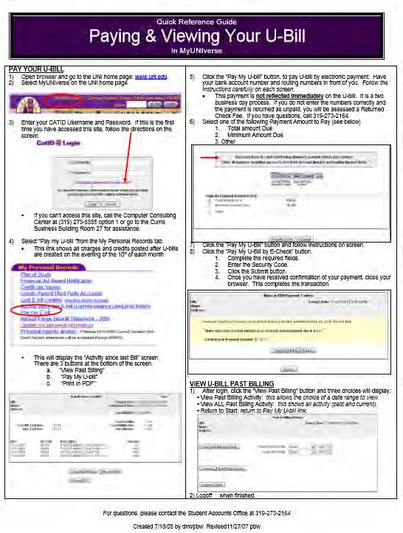

Due Dates
Your U-bill will be calculated and billed each month during the session. The billing date is usually the first of the month, and payment is usually due on the 20th of that month. For an up-to date list of U-Bill due dates, visit https://obo.uni.edu/student-accounts/due-dates-for-ubill.

Late Fees
If you do not pay your U-bill on time, a late fee will be added to your account. The late fee will be charged if your bill is 30 days or more past due. The rate is 1% of the amount past due and will be
charged each month the U-bill has a past due balance. For example, a past due bill of $1500.00 will be assessed a late fee of $15. A hold will also be placed on your account if you do not pay your U-bill on time.

ACCOUNT HOLDS
All CIEP students have a “CIEP Hold” on their account. Do not worry about this hold. However, you can also have a hold on your account for:
- Not paying your U-bill. The Office of Business Operations will place a hold on your account. You will need to pay your U-bill to remove it.
- Needing an additional vaccine or screening at the Student Health Clinic. The clinic will place a hold on your account. You will need to schedule and go to the appointment to remove the hold.
- If you are a conditionally admitted student, you can also have a hold from your academic advisor. You will need to schedule an appointment to meet with your advisor to remove the hold.
- If you are a conditionally admitted student, you will need to complete a series of training sessions to be conditionally admitted to UNI. An example is the sexual assault prevention training. If you do not complete these training sessions on time, a hold will be placed on your account.
- If you are a conditionally admitted student, you may need to update or submit your contact information for the university. A hold may be placed on your account until you submit updated information through MyUniverse.
It is important to take care of any holds on your account as soon as possible. If you have a hold on your account, the CIEP Office Staff will not be able to give you your grades or class schedule, and they will not be able to register you for your classes, which could affect your immigration status. Feel free to stop by the CIEP Main Office if you have any questions about your account.
STANDARD ENGLISH TESTS

TOEFL: Most academic institutions require nonnative students to show proof of their English proficiency in order to be admitted for academic classes. Most students submit an official Test of English as a Foreign Language (TOEFL) score report. The CIEP administers Institutional TOEFL exams as needed or by request. You may sign up to take the test for a fee. The test results are only valid for academic study at UNI. Undergraduate students must score 550 or above, and graduate students must score 500 or above for UNI.

IBT: You may sign up to take the internet based TOEFL (iBT) online and later take the test at the Academic Learning Center in the ITTC Building, room 7 on the UNI Campus. The UNI Examination & Evaluation Services through the Academic Learning Center gives the iBT test several times a year. The test results are valid for any and all colleges and universities worldwide.

More information about standard English tests is available on the UNI website at https://examservices.uni.edu/our-exams or by calling (319) 273-3926. To register for the test through ets.org, visit https://www.ets.org/toefl/test- takers/ibt/take/register.

STUDENT PROBLEMS/CONCERNS/GRIEVANCES
We hope your experience at the CIEP is rewarding and trouble-free. However, problems can happen and we want to help you solve them as quickly as possible.
If your problem is about your class grade, please see the Grade Appeals section of this handbook. If your problem is about insurance needs, application assistance, TOEFL exams, payment of fees, etc., please speak first to the CIEP Office staff. They will refer the problem to the director, if necessary. If your problem is not about your grade but involves a class, its books, its instructor, its exams, or other related issues, please speak to the instructor first. You may have to make an appointment to speak to the instructor outside of class.
If, at any time, your problem is not resolved to your satisfaction or involves something personal that you cannot discuss with your instructor or the office staff, please follow the steps listed below:
Steps for Problem Resolution:
- Complete a Formal Student Grievance Form by writing down your problem or situation, any dates, names of people, or other information (See Appendix A-3 for a copy of the Formal Student Grievance Form. Copies of this form are also available in the CIEP office).
- Give the form to the CIEP Office staff and wait for a reply from the CIEP Director.
- If necessary, meet with the CIEP Director to talk about the problem and look for solutions (see Grade Appeals).

CIEP CLASS EVALUATION
At the end of each session, you will be asked to complete an evaluation for each class you are enrolled in at the CIEP (see Appendix C-3 for a UNI CIEP Class – Teacher Evaluation Form). The purpose of the evaluation is for you to tell the CIEP about your feelings or complaints about the way you were taught, the instructor, the class, and the CIEP in general. It is also an opportunity for you to write your suggestions about how the CIEP can improve its classes and services.
After the session is complete and grades are recorded, your answers will be tabulated along with your classmates’ answers on a separate sheet of paper. Also, your written comments together with your classmates’ comments will be typed on a separate piece of paper and given to your teacher. Your original Teacher/Class Evaluations will stay with the CIEP Director and your name will not be included on the typed piece of paper with your comments nor will your name be on the piece of paper with the tabulations of everyone’s answers.
You are encouraged to be open and honest in making your answers. The information you provide will be used to improve the CIEP.

CIEP & Government Policies

VISA & IMMIGRATION STATUS
Like every country, the United States has laws for foreign students studying in the United States. You must follow these laws so you will not be deported.
You must have a passport and visa to enter the United States. Also, you must keep your passport valid at all times. If your passport will expire soon, contact your country’s embassy or consulate. As you enter the United States, you will also receive an electronic I-94 arrival/departure card. If you have questions about visa and immigration information, please contact the OIE Director or the Immigration and Advising Coordinator. Most CIEP students have an F-1 or a J-1 visa. Below is information about these two visas. For information regarding other student visa types, visit Student Visa (state.gov)

F-1 VISA
To be a full-time student in the United States you must have an F-1 visa. Your F-1 visa does not need to be renewed as long as you remain in status and do not leave the United States. However, if you leave the U.S. with an expired visa or are out of status when you leave, you must get a new visa to re-enter the U.S.
As an F-1 student, it is important that you maintain your immigration status. Your status with the U.S. Immigration & Customs Enforcement (ICE) can be terminated for: (1) failure to get off of academic probation, (2) failure to attend 80% of your classes, and (3) failure to pay tuition. You may file for reinstatement if your F-1 status is terminated; however, this is a lengthy process and approval by the ICE is not guaranteed.

Maintaining F-1 Status
It is your responsibility to maintain your immigration status. There are several important things you must do to maintain F-1 status:
  - Keep your passport up-to-date. If your passport expires, get a new one.
  - Enroll in the minimum number of credits: (12) hours for undergraduates, (9) hours for Master’s degree students, and (6) hours for PhD students; and maintain normal progress towards your certification in the program. For CIEP students, you must enroll in 3 classroom hours plus 1 hour lab in order to be a full-time student.
  - If you enter an academic program at UNI, be sure to get a new I-20 from International Admissions.
  - Do not work off-campus without authorization of the ICE. Also, talk with the CIEP Student Services Coordinator or the Immigration and Advising Coordinator on UNI's campus.
  - Attend the school listed on your I-20. If you have transferred schools, request a new I-20 from the new school and complete Appendix C-1 (UNI CIEP SEVIS Transfer-In Form).
  - Contact the CIEP Office if you plan to travel outside of the U.S. or transfer to another school. It may be necessary to notify the ICE and SEVIS. The CIEP will advise you in completing the necessary papers (see Appendix D-1 Notification of Absence Form).
  - Obtain extensions, as needed, for permission to stay in the U.S. beyond your time limit. Contact the CIEP about extension procedures.
  - Report any changes to your address, telephone number, or names of dependents to the CIEP.

J-1 VISA
The Exchange Visitor (J) nonimmigrant visa category is for individuals approved to participate in work- and study-based exchange visitor programs. You may not arrive more than 30 days before the program start date shown on your DS-2019. Upon completion of your exchange program, you have a grace period of 30 days to depart the United States.

Maintaining J-1 Status
It is your responsibility to maintain your immigration status. There are several important things you must do to maintain J-1 status:
  - Keep your passport up-to-date. If your passport expires, get a new one.
  - Perform only the activities listed on your DS2019 form and as stated in the regulations for that category of exchange.
  - Attend only the school and program listed on your DS-2019. If you want to transfer schools, you will have to get a new type of visa.
  - Contact the CIEP if you plan to travel outside of the U.S. Report any changes to your address, telephone number, or names of dependents to CIEP.
  - Your program may be extended by your program sponsor for up to its maximum length. If an extension is granted, a new DS-2019 Form will be issued to you reflecting the change. Designated sponsors are authorized to issue DS-2019 Form to prospective or current exchange visitors they select for their program. Contact the CIEP about extension procedures.
  - When you agree to participate in an Exchange Visitor Program, you will be subject to the two- year home-country foreign residency requirement if your exchange program is funded by either your government or the U.S. government, involves specialized knowledge or skills deemed necessary by your home country, or you received graduate medical training. If this requirement applies, you must return to your home country for a cumulative total of two years at the end of your exchange visitor program.
  - If you plan to withdraw from your program, you must notify your program sponsor. Your program sponsor will enter this information into SEVIS and you will be expected to depart the United States immediately. You will not be entitled to the post completion 30-day period because you did not successfully complete your program.
Regardless of your visa type, if you are changing your address, be sure to notify the following offices within ten days:
  - U.S Citizenship & Immigration Services (USCIS)
  - The International Students Office
  - The CIEP Office
  - Your residence hall office
  - The Registrar’s Office

ABSENCES
Immigration rules say that any student attending classes on an F-1 visa must attend class full time. Full time registration at the CIEP is 3 hours of class and 1 hour lab. If you are not sure of your immigration status, be sure to ask the CIEP Office or the Office of International Engagement.
There are no excused absences in CIEP. If you miss a test or homework assignment, you are responsible for learning the material missed. Your teacher may or may not accept the assignment or have a makeup test. Please be sure you understand the teacher’s policy for missed tests and homework (see Make-up Policy). If you know you will be absent for several days, please call (319-273-2182) or email (ciep@uni.edu) the main office. Excessive absences due to special circumstances should be discussed with your instructors as well as the CIEP Director.

ON CAMPUS JOBS
If you hold an F1 visa and would like to have a job on campus, you may look for one through the UNI Job Board. To find the UNI Job Board, log into your MyUNIverse and click on the “Work@UNI” tab. Find the section that says “Student Employment” and in the box called “Job Opportunities:” click on the “Online Job Board” link. After that, set your search filters to “on-campus” and “non-work study.” Then you will be able to look at job opportunities and be able to apply for the job.
Keep in mind that international students may only work 20 hours a week and cannot work in a co-op or work study position. International students are not permitted to work more than a total of 20 hours from all jobs during ANY week (Sunday through Saturday) while school is in session. There are no exceptions to this rule.

TAXES
All international students and scholars must file IRS form 8843 even if no income was earned during a calendar year. This is a simple form that you can do yourself. If you did earn income, you will need to file form 8843 along with a 1040 form (tax form).

All international students who are employed in the United States must file a tax form with the Internal Revenue Service by April 15th of each year. Filing a tax form provides proof of where you worked, when you worked, how much money you earned, and how much money was collected from your paychecks to pay for taxes. If you complete the form correctly and the amounts are verified, you may receive a refund check.
Free income tax assistance is offered to the public each year at the University of Northern Iowa through the Volunteer Income Tax Assistance (VITA) program. Senior and graduate accounting students provide the assistance. No appointment is necessary. If you seek VITA assistance, be sure to bring your I-20 or DS-2019 form, your passport, and all tax documents (W-2 and possibly 1042-S and 1099 forms) that were sent to you by your employer.
Professional tax preparation services are also available. If you would prefer to hire someone to do your taxes, search on the Internet for “Tax Return Preparation.” You may also prepare your income tax return yourself. To get started, read the information from the U.S. Internal Revenue Service at https://www.irs.gov/newsroom/resources-to-help-you-prepare-your-tax- return.

VACATION FROM STUDIES
You may take off an 8-week session from the CIEP to return home, travel, or simply take a rest. However, to take a session off or “vacation session” you must have completed four consecutive sessions (CIEP offers five sessions a year). For example, if you began the CIEP in August, you can take a session off beginning in June. Before leaving, please visit the CIEP Main Office in Bartlett 3025 and fill out a Notification of Absence Form (Appendix D-1).

Also, do not forget to get your I-20 signed if you are leaving the country and plan to return. If you decide to leave before you have completed four consecutive sessions in the program or decide to leave for longer than one session, you will have to make a new application and receive a new I-20 to return to the CIEP.

University of Northern Iowa

TRANSITIONING INTO ACADEMIC CLASSES
As a part-time or full-time CIEP student, you are eligible to apply and become a part-time or full-time UNI student in academic classes. Although admission into the CIEP does not mean admission into UNI academic classes, you have choices that are not available to non-CIEP students. As a CIEP student, you can be considered for full-time academic study if you have successfully completed the CIEP. The Office of International Admissions alone makes the final decision to admit undergraduate students to UNI academic classes.
If you are not a conditionally admitted student, you must apply first to the International Admission Office. After that, the International Admissions Office will request information about you from the CIEP Office and decide the worth of your application. For graduate admissions, you should apply to the individual department that you are interested in on campus. They, in turn, may contact the CIEP for a recommendation.

CONDITIONAL VS. DIRECT ADMISSION PROCEDURES
The procedure for CIEP students who have conditional admission and want to transition into academic classes is different than the procedure for students who are directly admitted to the CIEP.

Conditionally Admitted Students
If you are a conditionally admitted CIEP student, it means you applied to the University of Northern Iowa but failed to meet the minimum English language requirements to enter UNI, so you were conditionally admitted to UNI. This means you will be admitted to full-time academic study when you have met the requirements set by the Office of International Admissions. This also means that you are admitted conditionally to an academic program of study at UNI and your first obligation is to fulfill your English proficiency requirement—that is the condition of your admission. Therefore, you should focus on developing your English skills before taking academic courses. The Office of International Admissions will determine the CIEP classes you need to meet your conditional requirement.
Once you reach a certain level in the CIEP, you may be eligible to take some academic classes while taking CIEP classes. The CIEP will work with the Office of International Admissions to try to fit academic courses into your CIEP class schedule. You should make an appointment with the Admissions staff to discuss your intentions of taking academic classes. The Admissions Office will make the final decision about you taking academic classes at UNI.
If you have completed your CIEP classes, we encourage you to meet with the CIEP Director who will help you contact Admissions in order to begin enrolling in academic classes. The Admissions Office will make the final decision about you taking academic classes at UNI.

Directly Admitted Students
If you are a directly admitted CIEP student interested in taking academic undergraduate classes at UNI after CIEP, the first step is to apply to the University. When you apply, you will need to completely fill out the application form, submit an application fee, supply official transcripts from any schools that you have attended, supply proof of your English proficiency (such as a TOEFL or iBT score, or the CIEP Certificate of Completion), submit a financial statement and certification form, and submit a completed

International Student Advisor Report. Visit https://intladm.uni.edu/undergraduate for more information on International Undergraduate Admissions Requirements.

ACADEMIC ADVISING
All students must attend an academic advising session with International Admissions Assistant Director and/or their desired program of study academic advisor in order to determine their class schedule. For more information on academic advising visit http://uni.edu/advising/.

OFFICE OF INTERNATIONAL ADMISSIONS
Located in Gilchrist Hall within the University of Northern Iowa Office of Admissions, the Office of International Admissions is dedicated to recruiting, serving, and processing applications and inquiries from undergraduate and graduate international students interested in studying at UNI. For more information about the Office of International Admissions, visit https://intladm.uni.edu/.

MAJORS & MINORS AT UNI
If you decide to take academic classes, you will have to choose a degree program that you want to major in and if you want to also include a minor (if you are an undergraduate).
A major is the main subject that a student studies while in college, and it often reflects how a student feels about their career goals. A minor is a second area of study or specialization that a student is interested in learning more about. UNI offers over 90 different majors. For a complete listing of majors and minors offered at UNI, visit https://majors.uni.edu/majors-a-z.

ABOUT UNI
The University of Northern Iowa has many honors. UNI has consistently ranked high in the “Best in the Midwest” Princeton Review Best 368 College Rankings guide and was ranked second in the Midwest top public comprehensive universities by U.S. News and World Report for fifteen consecutive years.

OIE
The Office of International Engagement (OIE) provides the following services specifically for international students: information for prospective academic students, graduate and undergraduate application packets, foreign credential evaluation for graduate students, general assistance, personal counseling, immigration regulations for students, initial orientation for academic students, and government liaison support. The OIE is located on the second floor of Maucker Union, Room 113, and is open from 8:00-4:30 pm Monday-Friday. The telephone number is (319) 273-6421. You can find more about the International Services at https://isso.uni.edu/.

INTERNATIONAL STUDENT ORGANIZATIONS
There are many international student organizations at UNI. Student organizations are a good way to meet new people and get involved on campus. Current UNI International Student Organizations include the African Union, International Student Association, International Student Promoters, Indian Student Association, UNIdos, and the UNI Tibetan Students. For more information about these organizations, and a complete list of all UNI Student organizations, visit https://java.access.uni.edu/StudentOrgsDirectory/.

MAIL
To mail letters, the nearest campus locations are the University Bookstore on 23rd Street and the HyVee store on University Avenue. If you need to go to a main U.S. Post Office, there are two locations. One is located on 221 West 6th Street in Cedar Falls and another is at 300 Sycamore Street in downtown Waterloo. You can receive letters and packages at your residence hall or apartment every day except Sundays and legal holidays.
To send a letter or package, be sure that your envelope or package has the following information on it:
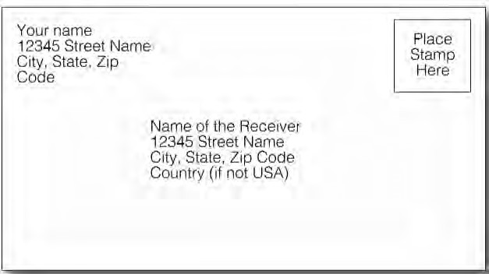

CHANGING YOUR STUDENT INFORMATION
Any time that you have a change in your address, phone number, or email you must inform the CIEP office. It is very important that we have all of your up to-date contact information in case we need to reach you. Email is particularly important because we send announcements about events, TOEFL, social activities, and CIEP changes via email.
You will receive a UNI email account when you become a student at UNI. You must use your UNI email account to receive emails from the CIEP staff and UNI offices. The CIEP will send important messages to you by your UNI email address only. Other email addresses will not be used by the staff and staff will not respond to emails from non-UNI email accounts (for example, Hotmail, Yahoo, Gmail, etc.) Therefore, you are responsible for reading your UNI email account messages regularly. Also, if you live off-campus and change your address you should notify the local post office by completing a Change of Address Form (available at University Book and Supply or the main post office buildings). Letters will be forwarded free of charge by the post office to your new address.
STUDENT RESOURCES
There are many resources available to students on campus for no extra fee.

Academic Learning Center
The Academic Learning Center has staff to help UNI students with their writing and math assignments. If you are taking non-CIEP classes, you are welcome to go to the Center for Academic Achievement Office for help. The staff will not proofread or edit your work, but they will help coach you in building your skills. The Center is located in the main floor of Rod Library and is open 8:00 – 4:30 pm Monday - Friday during the school year. Academic students are encouraged to make an appointment by calling 319-273-6023 or 319-273-2361. You can also visit the website at https://tlc.uni.edu/.

Wellness & Recreation Center (WRC)
The Wellness and Recreation Center is UNI’s main recreational facility on campus. You can take certification classes in CPR or First Aid; fitness and leisure classes like yoga, aerobics, and dance; play basketball or run on the track; rock climb; play racquetball; or use cardio and weight-lifting machines. There are also various outdoor recreation trips that the WRC offices offer for students such as winter camping, caving, backpacking, or canoeing. All WRC services are either free for UNI students or offered at a reduced price.

Rod Library
The UNI Rod Library has various academic, entertainment, and professional resources for students. If you need a quiet place to study, a place to make photocopies, a computer or laptop for a few hours, or have questions about searching for a resource, you can go to the library for answers.

Computer Labs
The University of Northern Iowa also has many computer labs on campus. The computer labs are for all students to use for email, homework, etc. The different labs are open at various times, and you will be able to find a lab to use at any time during regular business hours/days. The computer labs are called Student Computer Centers (SCCs) and provide convenient computing and network access for students, faculty, and staff in many locations on campus.
These Student Computer Centers are located in the Towers Center, Bridge Lounge, Campbell Hall, Computer Consulting Center in ITTC 36, Lang 113, Lawther Hall 124, Maucker Union, Panther Village, Redeker Center, Roth 120, Schindler 123, and the Wellness Center. Some computer labs that are in residence halls may be more difficult to access. Each Computer Center offers a variety of software applications, access to UNI’s email system, the Internet, and laser printing.
Important things to remember when using the SCCs:
  - No food or drink in the lab.
  - Do not download software onto the computers.
  - Use your own Google drive or email to save your work.
  - Do not shut down the computer, just log-off.
  - The lab monitor/assistant is there to help you.
  - Ask for help if you are not sure about something. Failure to follow the SCC rules can result in loss of access to the SCCs.
How to use the Student Computer Centers:
- Choose any Windows or Macintosh computer that is not in use.
- Log into the Validation program (the system that allows you to log-into UNI computers at any time) by pressing Ctrl+Alt+Delete all at the same time.
- Once you are at your station, select the software you would like to use from the START menu. You may run your own software; however, you are NOT allowed to add or save anything to the hard drive (thus installation of software is not permitted).
- You will need access to your Google drive in order to save your work.
Logging onto a Computer in the SCCs:
- Username: The Log-In screen will ask you for your UNI Username (your Username is ONLY the portion before the @ sign in your UNI email address). For example, “johndoe@uni.edu” will log-in with the username “johndoe”.
- Passphrase: Use the passphrase that you set up during orientation and use to log-in to your UNI email and MyUniverse.
- Auto-logout: After ten minutes of not using the computer, a message will appear and you will then have ten additional minutes to click cancel in order to bring you back to your desktop. If you do not click cancel you will then be logged off of the computer.

Student Accessibility Services
If you have a disability or would like to request accommodations for your classes or campus experience, the University of Northern Iowa has resources to provide specialized services to help students in their academic, career, and personal development. The Student Accessibility Services Office at UNI offers many different services and works to allow equal access to education and university life. If you want services for a disability or would like to request accommodations, you can contact Student Accessibility Services as soon as possible to arrange for support. You can call 319-273-2676, fax 319-273-6884, or visit the website https://sas.uni.edu/.

PUBLIC SAFETY
The UNI campus is one the safest in the country, yet precautions are made to make life safe for students. Click here https://publicsafety.uni.edu/crime-prevention-safety-tips for a list of helpful advice from the UNI Public Safety website https://publicsafety.uni.edu/.

PARKING PERMITS
If you want to park your car on the UNI campus, you will need to have a UNI parking permit from UNI Public Safety. You can find more information about purchasing a UNI parking permit by visiting https://publicsafety.uni.edu/parking-division-vehicle-permits or by visiting the Department of Public Safety office located in the Gilchrist Building on the UNI campus.

HOUSING
Students living on campus in the residence halls come from everywhere including Iowa, other states in the United States, and other countries. To live in the residence halls, you must be registered as a UNI student. There are also campus apartments and married student housing at UNI. All residence halls are open during academic breaks during the academic year. You must sign a housing contract for any on- campus residence. Contracts differ depending on the length of time and type of residence. For more information about on-campus housing and meal plans, please see the UNI Department of Residence website at https://dor.uni.edu/.

Interim Housing
Only certain residence halls are open for students to live in during the breaks. Visit https://dor.uni.edu/residence-halls to see which halls are open over the breaks. You can also talk to your RA and your residence hall secretary to find out more information about living on campus over the breaks.

Dining & Meal Plans
Students living in residence halls must purchase meal plans, which are an amount of meals you have for the school year. These plans have different prices too. For information on different types of meal plans, visit https://dor.uni.edu/dining/meal-plans-2019-20. You may use these meal plans to eat in the on- campus dining centers: Piazza and Rialto. Some meal plans also include dining dollars, which you can use at retail locations around campus. Retail locations around campus can be found in the Maucker Union, 23rd Street Market, Redeker Center, Rod Library, Schindler Education Center, Curris Business Building, and the Wellness and Recreation Center.

Laundry
Laundry facilities are available in the residence halls if you are a resident of the dorms. The machines are operated by your UNI ID card and the cost is included in your housing bill.

LIVING OFF CAMPUS
If you choose to live off-campus, you will need to find an apartment. There are many apartments located close to the UNI campus. For more information about apartments search the internet, using websites like apartments.com. If your apartment (building) does not include laundry facilities, you will have to use a laundromat. We do not assist with find off-campus housing.
Useful terms to know when looking for apartments:
- Unfurnished: apartment contains no furniture but usually has a stove, oven, and refrigerator.
- Furnished: apartment contains furniture including bed, sofa, chairs, and table.
- Utilities Included: the rent money you pay includes the cost of heating, water, and electricity.
- Utilities Not Included: the rent money you pay does not include the cost of heat, water, and electricity.
- AC: air conditioned.
- Lease: the agreement or contract you sign to rent the apartment (usually leases can be for 9- 12 months).
- Security Deposit: when you sign a lease, you must also include extra money (usually one month’s rent) as insurance that you will not damage the property.
- Landlord: the property owner.

HEALTH

Required Immunizations & Vaccinations
Measles Immunization: Measles, which is commonly thought of as a childhood illness, is also potentially very serious for adults. It is highly contagious. Measles immunizations have been commonly required of all school age children in the United States for many years. The University of Northern Iowa requires documentation of measles immunization from ALL students. You will be considered immune to measles with proof of one of the following:
  - A physician’s dated statement indicating that you had measles and your age at the time of illness.
  - A physician’s dated statement that you received your most recent measles vaccination after 1980.
  - Laboratory (serologic) evidence of measles immunity.
  - If you were born before 1957, you will not need to provide immunization information.
Also, you are required to take a TB (tuberculosis) test. You will be exempt (not required) to provide verification or receive immunizations for two reasons:
  - Medical reasons: If you qualify to be exempt for medical reasons, you must provide a statement that the immunization is not advised for medical reasons. The statement must be signed by a physician. You are also exempt if you are a woman who knows or suspects that you are pregnant.
  - Religious reasons: An exemption may be granted to you if you are a member of a recognized religious denomination in which the beliefs and practices of the religious denomination conflict with immunizations.

Health Insurance
You must have health insurance to be a student at UNI and the CIEP. If you are already covered by insurance from an American company from your own country, you must bring proof of your insurance information to the UNI Student Health Center. In order to waive the mandatory insurance enrollment, you must meet one of the following criteria:
  - Government-sponsored students whose home government purchases insurance for students and does not just supply funds to purchase an insurance plan of their choice (Example: Government of Kuwait, Saudi Mission).
  - Corporate health insurance provided by an employer in the U.S. (Example: John Deere & Co.).
  - Other comparable coverage that meets the requirements of the university policy and is approved by the UNI Student Health Clinic. For more information regarding international student health insurance, visit https://health.uni.edu/insurance/international or stop by the UNI Student Health Clinic.

Medical Services
If possible, you should call and make an appointment before going to the UNI Student Health Center (located on 23rd Street, near Schindler Education Center). This will ensure that you will see a nurse and/or doctor at that time. You can call 319-273-2009 to make an appointment. Be sure to bring your student ID card and your health insurance card to your appointment. When you arrive at the UNI Student Health Center, check in at the front desk and be sure to inform the staff if it is your first time coming to the UNI Student Health Center.
If it is your first visit, you will be required to complete a Medical History Form that asks about any illnesses or conditions you or anyone in your family has had or may have. This is necessary to best serve your medical needs. You will also be asked to provide a copy of your insurance card.
If the clinic is not open or you cannot make an appointment at the time that you want, you can go to the emergency room if your condition is not good. If you become sick and do not feel well but it is not an emergency: Contact the UNI Student Health Center to make an appointment.
If the Health Center is closed, contact your resident advisor (RA) in your residence hall. If your RA (or another RA) is not available and you are worried, contact UNI Police at 319-273-4000. The UNI Police can be contacted 24 hours/day.
Here is a list of some of the things that you may go to the clinic or the emergency room for:

Go to the Student Health Center | Go to the Emergency Room
Cold, cough or flu | Difficulty breathing or shortness of breath
Minor aches and pains like an earache | Fainting, sudden dizziness, and weakness
Insect bite | Changes in vision
Sunburn | Confusion
Sexually transmitted disease | Deep cuts or uncontrolled bleeding
Fever that lasts for more than 12 hours | Uncontrollable long-term headache
Sore throat or swollen glands | Poisoning
Minor rash | Loss of consciousness, convulsion
Minor sprain | Broken bones or very painful sprain
Minor cuts and bruises | Persistent diarrhea or vomiting
 | Sudden or severe pain, especially chest pain
 | Pain or pressure in your chest or upper abdomen

Weekend Medical Services
If you become sick or need emergency care in the evenings or on the weekend, you may seek care from your family doctor, an urgent care center, or even the hospital emergency room. Please remember that hospital emergency rooms are for emergencies only such as an accident, a serious illness, or serious injury. All medical care facilities will require insurance information. If you seek care outside of the UNI Student Health Clinic, you may need to complete insurance forms.

Hospitals & Clinics in the area:
Sartori Memorial Hospital Allen Hospital
515 College Street, Cedar Falls 1825 Logan Avenue, Waterloo
319-268-3000 319-235-3702

Covenant Medical Center
3421 W. 9th Street, Waterloo
319-272-8000

For life threatening emergencies at any time, day or night, call 9-1-1 for the police, ambulance, or fire department. (From an on-campus phone, dial 9-911)

Emergency Resources
If you find that you need assistance for any reason, there are groups and organizations at UNI and in Cedar Falls that you can go to for help.
If you are experiencing thoughts of suicide, depression, debilitating anxiety, or substance abuse contact the UNI Counseling Center at 273-2676. For more information on the UNI Counseling Center, visit https://counseling.uni.edu/. After hours, contact UNI Public Safety at 273-2712 and they will contact the on-call counseling center staff member to assist you. You may also contact 24-Hour crisis lines such as the National Suicide Hotline at 1-800-784-2433 and the Foundation 2 Crisis Line at 1-800-332-4224.
If you feel as though you are in physical danger, contact the UNI Police at 273-2712 or call 911 if you are in immediate physical danger.
If you become a victim of sexual assault or violence, contact Violence Intervention Services at 273-2137. You may also contact the University Title IX Officer at 273-2846. If you feel discriminated against based on your gender, race, sexual orientation, or as though any of your civil rights have been violated, contact the UNI Office of Compliance and Equity Management at 273-2846 or visit their website at https://equity.uni.edu/.
EMERGENCY PROCEDURES
Important information for all emergencies:
  - Report all emergencies by dialing 911 or 319-273-4000.
  - Classes are suspended in the affected area for the duration of the emergency.
  - Always follow instructions provided by emergency personnel, UNI ALERT, and campus officials.
  - Stay away from the affected area until given the “all clear” by emergency personnel.
  - Whenever possible, assist persons with special needs.
Building Evacuation
Evacuation may be required due to fire, hazardous materials release, bomb threat, or other emergency. If this happens:
  - Gather personal belongings if safe to do so. DO NOT delay evacuation.
  - Immediately evacuate the building using the nearest safely accessible exit.
  - DO NOT use elevators.
  - Meet outside the building and await further instructions.
  - Assist persons with special needs as able.
Threatening Person/Armed Intruder
  - If the person approaches you, your actions will depend solely on your judgment and capabilities. No strategy is 100 percent effective.
  - Do not confront the person.
  - Call 911. Provide as much information as possible about the person and direction of travel.
  - Do not block the person’s access to an exit.
If you hear gunfire or see a person with a weapon, take immediate steps to protect yourself.
- Try to escape the area if able.
- If unable to escape, immediately close and lock or barricade the door.
- Stay away from windows and out of view. Turn off lights. Hide behind heavy furnishings if possible.
- If you are in an open area and cannot escape, find a room to hide in.
Fire
- If you smell smoke or witness a fire, activate the nearest fire-alarm pull station.
- Evacuate the building immediately when the alarm is activated or there is evidence of a fire.
- If you are the last to leave a room, office or building, close doors as exiting.
- After evacuating, call 911 to report the location of fire or smoke.
Tornado Warning
- Immediately seek shelter in designated severe-weather shelters (interior areas of lower level of building away from windows).
- Stay in a designated shelter until warning expires.
Shelter-in-Place
Shelter-in-place may be required due to hazardous materials release, acts of violence, or other emergency.
- Instructions will be issued via UNI ALERT and other available emergency notification systems.
- Stay calm.
- Stay away from windows, doors, and outside walls.
Suspicious Object
- Do not touch or disturb the object or package. Find a room to hide in.
- Do not use your cell phone near the object in question.
- Call 911 and notify someone in charge of the area

For more information, see https://uni.edu/resources/alert

Culture & Community

CULTURE SHOCK
When moving to a new community, especially in a different culture, students often experience “Culture Shock.” Culture Shock is the feeling you experience when you are taken out of a familiar environment and placed into a new one. It is normal for a visiting student to feel depressed and isolated. You may feel frustrated and confused with foreign ways and speech, but understanding Americans’ behavior will help you understand your own feelings. Some helpful ways to cope with culture shock are:
  - Go out: Don’t sit in your apartment or the library every day. Find some campus activities that sound interesting to you. By getting out and into social settings, you will begin to become more comfortable with new customs. You can join in activities through the CIEP or the Office of International Engagement.
  - Get exercise: Exercise has been shown to reduce stress and fight depression. Take a walk downtown or join an intramural sports team. Find some fellow students who want to get active, and schedule a regular activity. As a CIEP student, you are able to use the WRC at UNI for free.
  - Make friends: Make an effort to become friends with both Americans and with other international students. The international students will be able to relate to your feelings and may be able to offer advice and support. American friends can answer general questions you have about life in the U.S. By making new friends, you will reduce feelings of loneliness and will begin to form bonds with your new surroundings.
  - Learn about the new culture: Resist the urge to judge behaviors or practices that are different from your own as being “bad” or “unintelligent.” Instead, try to learn the reason behind the behavior. While you may not agree with the practice, you will have a better understanding of how to respond when faced with it.
  - Seek assistance: If you find that you cannot seem to adjust to the new culture, make an appointment to speak with one of the staff in the Office of International Engagement. If you find that you are very depressed, make an appointment with the Counseling Center. In both cases, your meeting will be completely confidential.
  - Be patient: Most people require several weeks or more to feel comfortable in a new culture. Give yourself time to adjust. Focus on the positive experiences, and try to view negative experiences as learning opportunities.
  - Sleep: Get plenty of sleep.
  - Be positive: Try to think through your feelings and be positive about your experience. Have an open mind and a sense of humor. Be hopeful, but do not avoid negative feelings that need to be expressed.
  - Be comfortable: Make your new home as comfortable as possible.
  - Keep a diary or journal: This helps to express your feelings. It may also be an interesting record of the changes that happen over time.

AMERICAN CULTURAL HABITS

Greetings
In the U.S., “Hi, how are you?” “Hello, how are you?” or, when introduced for the first time, “I’m pleased to meet you,” are the most common forms of greeting. “So long,” “See you soon,” “See you later,” and “We should get together sometime” are also common expressions used for saying goodbye. An expression such as, “Hello, how are you?” does not require a lengthy response but can be answered by saying, “Fine, thank you” or “Good, and you?” Also, “See you soon” or “Later” are not promises to get in contact with you, instead, they are simply ways to say “Good-bye.”

Names & Titles
First names are commonly used in the United States. People may call each other by their first names immediately after they have met. Americans often use first names even with persons of a different age and status. However, there are some small differences in vocabulary and manner, depending on the relationship between the people involved. For example, an American is less likely to use slang when speaking to a person who is older, whose social standing is higher, or whom she or he does not know very well. Any faculty member can be addressed as “Professor” whether she or he holds the rank of assistant professor, associate professor, or full professor. Again, people might ask you to address them by their first names.
A “nickname” is not the person’s real name but a shorter name used by them among friends. The use of nicknames is fairly common among friends. International students often use nicknames if their own names seem long and unpronounceable to Americans. For example, a student whose name is Takashi might come to be known as “Taka.” Being called by a nickname is not viewed as negative and is completely optional.

Unspoken Language
Gestures and body language mean different things in different cultures. To avoid misunderstandings, be careful about the gestures you exchange with people from other cultures. In the United States, shaking
hands is common in formal introductions and often goes with “How do you do?”, “Nice to meet you” or “Nice to see you again.”

Social Equity
Americans expect all people to respect an individual regardless of occupation, disability, sex, race, religion, or sexual orientation. All individuals you meet will expect the same consideration and courtesy.
Both men and women in the United States have an active part in community life. Most women have jobs outside of the home and, in many cases, both parents take care of small children and share home chores. A woman’s status in the United States is different than in some other countries.
American women have much personal freedom, and it is not unusual for unmarried women or men in the U.S. to live alone or share households with others. In addition, it is not unusual for an unmarried woman or man to go to public places without companions.
Drink
Tap water is safe to drink and used by many Americans as their normal drinking water. Americans generally do not drink alcoholic beverages with their meals. However, alcoholic beverages are frequently served at meals when guests are present. If you are offered an alcoholic beverage, it is acceptable to decline. In Iowa, it is illegal for anyone under the age of 21 to drink alcohol. Service people in bars, restaurants, and other establishments will ask for your identification to verify your age.

Time
There are four time zones in the continental United States. These are (from east to west) Eastern Time, Central Time, Mountain Time, and Pacific Time. Iowa is in the Central Time Zone (GMT-06:00). In addition, the U.S. has Daylight Savings Time from March to November. This begins on the second Sunday in March and ends on the first Sunday in November. In April, one hour is added to the clocks (if it was 7pm, it is now 8pm). In October, one hour is subtracted from the clocks and Daylight Savings Time ends.
Being on time is very important in American society. School, plays, concerts, meetings, weddings, and formal dinners begin on time. It is impolite to be late. Please arrive a little early for your appointments with a professor, medical doctor, or other professional. In informal social occasions such as parties and dinners, time is less important.

Cleanliness
Americans put great emphasis on personal cleanliness. Most Americans are sensitive to body odors, even their own. For this reason, most Americans bathe once a day (and sometimes more during hot weather or after exercise), use deodorant or an antiperspirant, and wash their clothes frequently.

Smoking
A number of Americans smoke, but many Americans dislike being exposed to the cigarette smoke of others. Therefore, do not assume that it is acceptable to smoke indoors. This is especially true in American homes. You should always ask if it is acceptable to smoke before you begin. Most public
buildings, buses, airplanes, and trains do not allow smoking. All public areas in Iowa, including bars, restaurants, and stores, do NOT allow smoking.

Space/Privacy
Most Americans like to keep some distance between each other when talking, walking, and standing in elevators or elsewhere. Sometimes contact is unavoidable and a person will say, “Excuse me.” In addition, Americans generally like to make eye contact while talking with one another and generally stand two to three feet apart. A closer distance will make them feel crowded and uncomfortable unless they are very familiar with the person. They may stand closer when speaking to family members or intimate friends. Personal space is important to them, as is minimizing physical contact with others.
As friendly gestures, Americans may pat others on the upper back or shoulder, or they might briefly touch another person’s arm. Close friends may hug. Generally, you will find that the atmosphere in a
U.S. university is more relaxed than it is in other countries. However, while Americans tend to be informal, there is great importance on personal privacy. If a professor is friendly with students, this does not mean you can call them at the office or at home without first making an appointment.

Friendship
Although Americans greatly value individuality, independence, and personal privacy; they are generally open and warm people. If you want to get to know someone, it is often wise to ask the person to join you for coffee or to get together to study. Such short events may prove to be the beginning of a strong and long-lasting friendship.
Social Invitations
If the host of a party or gathering invites you to an event over the phone, in person, or via a written invitation, the invitation is usually only for you unless the host specifically invites your family or friends. Bringing your own guest without asking for the host’s permission ahead of time is considered impolite.
When accepting an invitation for a meal, be sure to tell your host about any foods you are unable to eat. This will help the host plan food and drink for everyone to enjoy together. If you must refuse something after it is prepared, refuse politely. It is polite to ask for any food on the dinner table (for example, “Would you please pass me the vegetables?”) since a request for more food is considered a compliment to the host.
Sometimes events will be potluck dinners. At these dinners you bring food to share with others. Social events with others can either be formal or informal. You should ask the host what to wear if the invitation does not give you an idea. It is not necessary to bring a gift for the host unless it is a special occasion (such as a birthday or an important holiday).

SHOPPING IN THE US
In stores, bargaining or negotiating prices is not practiced in the United States. However, you can bargain prices for large items like cars, washing machines, and houses.
When buying things, be sure you understand the store’s rules for returning them. Remember to keep your sales receipt because you will need it if there is a problem and you must return your purchase. Some products also have a warranty, but you must mail (or sometimes email) the warranty card to the
manufacturer. Ask the salesperson about the store’s return/refund and service policy. If you do not like the answer, shop somewhere else. Most stores will allow you to return something in good condition and with a receipt or proof of purchase, but others will not.
In Iowa, you must pay a state/local sales tax. This is automatically added to the cost of the item at the register. It is not included on the price tag.

Supermarkets
Supermarkets offer a variety of products for you to purchase that you may normally buy in several shops. These stores will usually include fresh, canned, dried and frozen fruits and vegetables, meats, baked goods, laundry and cleaning supplies, paper products, personal needs, non-prescription drugs, beverages, and many other items. Supermarkets are open daily and sometimes they are open 24 hours. Places like Aldi and Fareway sell food items at lower prices than some other stores. Purchases can be made by cash, credit card, debit card, or check. Some stores, however, may not accept all types of payment or may require additional identification such as a driver’s license.

Drug Stores/Pharmacies
Drug stores/pharmacies have a registered pharmacist who will provide you with the medicine that your doctor has prescribed. These stores also sell many items such as magazines, cigarettes, candy, newspapers, personal items, film, and often a place to print photos.

Discount/Department Stores
There are discount/department stores that have prices lower than other stores and sell a wide variety of merchandise. Check things carefully to be sure that they are what you expect. Some of the big discount stores in the area are Wal-Mart, Target, K-Mart, and Sam’s Club.

Thrift Shops
Thrift shops sell used clothing, furniture, household items, and many other things. Some of them are operated by religious or charitable organizations such as Saint Vincent de Paul or Goodwill. These are most likely the places where you will find items for the least amount of money.

Garage Sales
Many people will have garage sales in/at their homes. At these garage sales they offer used items for sale at a very cheap price. The owner will ask for a price but you can bargain for a lower price. These garage sales are typically on Saturdays during the spring, summer, and fall months. They will be announced by notices on bulletin boards, signs in yards, and classified ads in the Northern Iowan, Waterloo Courier, and Hometowner newspapers.

Coupons
Coupons are paper promotions available in magazines, newspapers, and mailed ads. Some may be cut out and used to reduce the price of a specific product when it is purchased. Other coupons can be downloaded from the internet. You can use coupons by giving the appropriate coupon to the sales clerk when you are buying the specific product on the coupon.
*For shopping locations, you can check Google Maps or other Internet search engines, or ask some of your instructors where they are located.

TIPPING
Service charges are often, but not always, added to your bill in American hotels, restaurants, and hair salons. However, tips are expected and needed by the employees. In restaurants, average tipping is 15% of your total bill, or more depending on how good the service was. You can visit this website to use an online tip calculator http://www.onlineconversion.com/tip_calculator.html or download the app on a smartphone.

HOLIDAYS
These holidays are celebrated almost everywhere in the United States. Schools are closed for all of them except Halloween. Stores, banks, post offices, and other government offices may close or have reduced hours for some of these holidays. UNI is closed for New Years, Martin Luther King Jr. Day, Memorial Day, Independence Day, Labor Day, Thanksgiving, and Christmas.
- New Year’s Day: January 1 marks the beginning of the year. Celebrating starts the night before, known as New Year’s Eve, and continues until the countdown to midnight.
- Martin Luther King Day: The 3rd Monday in January marks the celebration of Reverend Dr. Martin Luther King, Jr., an assassinated civil rights leader.
- President’s Day: On the Friday between February 12th (President Lincoln’s birthday) and February 22nd (President Washington’s Birthday), Americans celebrate these U.S. President’s dates of birth.
- Memorial Day: The last Monday in May honors those who have died in war.
- Flag Day: June 14th is a day in which Americans mark the adoption of the American flag.
- Independence Day: July 4 marks the celebration of the birthday of the United States.
- Labor Day: The first Monday in September is a day of rest to honor workers.
- Columbus Day: On October 12, or the Monday closest to that day, Americans celebrate Christopher Columbus, an explorer who landed on the shore of North America.
- Halloween: October 31 is a fun holiday/festival to dress up, usually, but not only, celebrated by children.
- Thanksgiving Day: The fourth Thursday in November is a day that Americans give thanks for many things.
- Christmas: December 25 is a Christian holiday celebrating the birth of Jesus of Nazareth.

ONLINE SAFETY TIPS
When you use the Internet, it is important to comply with the law and keep yourself and your information protected. Even though UNI does not monitor ResNet, a network that checks for copyright violations, it does comply with infringement notifications in accordance with the DCMA (Digital Millennium Copyright Act). Copyright owners do monitor peer to peer networks for intellectual property misuse, and under the law
UNI has an obligation to respond to various legal notices from copyright owners or their representatives.
In order to comply with the Digital Millennium Copyright Act, it is important that you protect yourself online. To do this, it is recommended that you remove any and all peer to peer file sharing programs on your computer. Peer to peer file sharing is used to both download files and make them available for upload to other computers.
LimeWire, Kazaa, FrostWire, and BitTorrent are examples of peer to peer file sharing programs. When you use these programs, you directly violate copyright law, but you also open up your computer to potential hackers and viruses or spyware.
To avoid copyright infringement and potential hackers and viruses, you should remove any peer to peer programs installed on your computer. You should also make sure to obtain copyright material legally using legal downloading services such as iTunes, Napster, Google Play, Rhapsody, or Amazon.
For more information regarding file sharing programs, visit https://its.uchicago.edu/file-sharing-policy/. For more information regarding US Copyright laws, visit http://www.copyright.gov/.

TEMPERATURE & WEIGHT CONVERSIONS
International measure uses the same definition of the units involved as is used in the UK and other Commonwealth countries. U.S. survey measure uses an older definition of these units which the United States used prior to adopting international measure.
For more detailed information, visit https://www.calculator.net/conversion-calculator.html. To view an online conversion website, visit http:// www.metric-conversions.org/.

CIEP GRADUATION
Once students have completed the CIEP and received their certificate, they go on to do many things. To get a Certificate of Completion you have to complete all the CIEP classes assigned to you by CIEP. If the CIEP waives you from taking the class because you initially tested out of the class at placement, you are not assigned the class and this class is not required. If you do not attend all the classes assigned to you because UNI Admissions Office does not require you to take the class, you have not completed all the CIEP classes assigned to you, and you will receive a Certificate of Participation. The CIEP will also provide you a Certificate of Participation if you complete at least one CIEP class. You can pick up your certificate in the CIEP office or we can mail it to you.
Here are a few ideas for students who want to know what they can do after completing or taking classes at the CIEP:
  - Apply to an academic program
  - Start or finish your career
  - Travel the world

COMMUNITY COLLEGES
Some CIEP students may benefit from going to a community college. In the U.S., community colleges provide two types of programs. The first type allows students to transfer to a 4-year college or university after finishing the 2-year Associate of Arts degree. Many students from the U.S. choose this option because most community colleges are small and the work may be easier.
The second type of program at community colleges prepares students for a career in one or two years. Information about Iowa community colleges can be reviewed online. For information about 2-year colleges in the U.S., students may go to the Reference section of the UNI Library and ask for the reviews on 2-year colleges.

TROUBLE WITH THE LAW
If you are accused of violating the law and you are taken into custody (arrested) by law enforcement officials, you have the right to know why you are being detained and you have the right to make a certain number of telephone calls to contact family members or others who you choose to notify or seek assistance from. You are entitled to consult with a lawyer if arrested, so you may respectfully request this of authorities. In many cases, a public defense attorney will be appointed to your case unless you have chosen your own attorney. You have the right not to answer law enforcement officer’s questions without a lawyer present.
If law enforcement officials arrest you and take you into custody for alleged immigration offenses, we recommend that you seek the assistance of an attorney who specializes in immigration cases. A directory of licensed immigration attorneys is available from the American Immigration Lawyers Association here: http://www.ailalawyer.com/.

Consular Notification
U.S. law enforcement officials who make arrests are required in some cases to notify the consulate or embassy representing the foreign national in the U.S. Countries where this notification is mandatory are: Albania, Algeria, Antigua and Barbuda, Armenia, Azerbaijan, Bahamas, Barbados, Belarus, Ghana, Grenada, Guyana, Hungary, Jamaica, Kazakhstan, Kiribati, Kuwait, Saint Lucia, Saint Vincent and the Grenadines, Seychelles, Sierra Leone, Singapore, Slovakia, Tajikistan, Belize, Brunei, Bulgaria, China (including Macao and Hong Kong), Costa Rica, Cyprus, Czech Republic, Dominica, Fiji, Gambia, Georgia, Kyrgyzstan, Malaysia, Malta, Mauritius, Moldova, Mongolia, Nigeria, Philippines, Poland, Romania, Russia, Saint Kitts and Nevis, Tanzania, Tonga, Trinidad and Tobago, Tunisia, Turkmenistan, Tuvalu, Ukraine, United Kingdom, Uzbekistan, Zambia, Zimbabwe.
Consular notification is an area addressed by the Vienna Convention on Diplomatic Relations: http://untreaty.un.org/cod/avl/ha/vcdr/vcdr.html.
If you are from a country not on this list, you may request to have your embassy notified. Additional information about this topic is available at http://travel.state.gov/law/consular/consular_753.html.

SOCIAL SECURITY
A Social Security Number (SSN) is required for you to work in the United States. If you are employed by UNI, the Payroll Office must have your SSN in order to give you a paycheck.

Social Security numbers will be assigned to those students who have obtained employment on-campus. Applications are available in the International Students and Scholars Office and in order to apply, you must have a job on-campus. Also, you have to present, in person, your I-94 (a square, white card that should be stapled into your passport), I-20 form, a letter from the CIEP Director stating that you are a student and eligible to work, and a complete application form to the Social Security Office.
If you have questions about getting a SSN, you can visit the Social Security Office at 3121 Greyhound Dr, Waterloo, IA or call 1-888-456-9554. About 6 weeks from the date of application you will receive a card with your Social Security Number on it in the mail. However, you may obtain the number assigned to you if you call the Social Security Office (319-234-1554) about 2 weeks after completing the application form.

REQUIRED RECORDS
In order to keep proper records as required by the United States Immigration Service, we need to photocopy certain information. ALL students are expected to bring their passport, visa, I-94, I-20, and insurance card to the CIEP office during the first week of their first CIEP session.

UNI Student ID
Your student ID is proof that you are a student at UNI. You should keep your student ID with you at all times. If you lose your student ID, there is a fee to replace it.

Age Verification
You can get a State of Iowa identification card at the Iowa Department of Transportation Driver’s License Bureau. This ID is proof of your identity and age. If you use a credit card, apply for a phone contract, or open and use any accounts, your ID will be required.

International Student
You can get an international student identification card to provide worldwide proof that you are an international student. This card will allow you to obtain discounts in the countries where you travel. Information and application procedures about the international student identification card are available in the Office of International Engagement; Maucker Union, Room 113. You will have to provide a 1” x 1” picture of yourself and payment for the processing fee.

CEDAR FALLS
Cedar Falls was founded in 1845 by William Sturgis. It was originally named Sturgis Falls, for the first family who settled on the site, but the Sturgis family moved on and the city was renamed Cedar Falls because of its proximity to the Cedar River. Because of the availability of water power, Cedar Falls developed as a milling and industrial center prior to the Civil War (1861-1865).
In 1876, the Iowa State Normal School was founded in Cedar Falls to train teachers for schools in the state of Iowa. As the school continued to grow and develop, it was renamed the University of Northern Iowa. Today, the city is home to several companies, both large and small, including an industrial park with more than 125 businesses.
The population of the surrounding Cedar Valley, is about 125,000 people and Cedar Falls accounts for about 37,000 of those people. The cost of living is below the national average and far below the cost of living in larger urban areas.
The Cedar Valley area offers a rich diversity of cultural opportunities including art galleries, museums, libraries, theaters, and a variety of performing arts venues such as the beautiful Gallagher-Bluedorn Performing Arts Center at the University of Northern Iowa.

WEATHER
Iowa weather can change very quickly. In the winter months of December, January, and February, expect temperatures below zero degrees Celsius. Be sure to have warm clothing such as heavy coats, scarves, gloves, and boots. If there is bad weather (like a big snow storm), the University and the CIEP may close their offices.
If the University of Northern Iowa is closed due to severe weather, the CIEP may also close and classes will most likely be moved to online. Check your email or Blackboard page for an announcement from your teacher. If you do not show up even though class is no longer in-person, you will still be counted absent. If you are not sure, please call the CIEP office (273-2182) after 8 a.m. or check the UNI Web site (www.uni.edu). You can also watch the local news or listen to it on the radio for information about closings of buildings on campus or other places around the community.
In the summer months of June, July, and August, expect hot, humid days. Drink lots of water to prevent dehydration. In case of Tornado and Severe Weather Watch:
Tornado or Severe Weather Watch
  - Means conditions are right for a tornado or severe weather.
  - Staff should be alert to weather conditions.
  - Alert siren is NOT sounded Tornado or Severe Weather Warning
  - Means a tornado/severe weather is sighted or indicated on the weather radar.
  - When the alert siren sounds, remain calm and avoid panic.
  - Proceed quickly and safely to area of shelter, NO ONE should leave the building.
  - Areas of safety are rooms and corridors on the lowest floor or basement in the innermost part of a building. If outside, seek shelter indoors. If no shelter is nearby, find the lowest point or depression possible. DO NOT stay in underpasses of roads.
  - Areas to avoid - stay clear of windows, corridors with windows, or large, free standing expanses.
  - Assist individuals who have trouble moving during weather related emergencies.
  - Stay in the shelter area until the severe conditions pass or an “All Clear” message has been transmitted over the emergency broadcast system or local radio or television stations.
  - After leaving the shelter area, report to the designated person/phone number to assist in accounting for all employees.
  - After the tornado has passed, evaluate the situation and if emergency help is needed, call UNI Public Safety at 3-4000.
  - Be aware of dangerous structural conditions and downed power lines. Report damaged facilities to Physical Plant at 3-4400.
  - Be alert for fires, gas leaks, and power failures.

There is no guaranteed safe place during a tornado. However, it is important to seek shelter in the best location to help minimize your exposure.

RELIGIOUS INSTITUTIONS
There are a number of religious institutions that practice different faiths in Cedar Falls and Waterloo. You can visit https://www.bestplaces.net/religion/city/iowa/cedar_falls to see the percentage breakdown of religions in Cedar Falls and Waterloo. To view of list of places of worship in the Cedar Valley, visit https://www.cedarfallstourism.org/about-cedar-falls/communities-of-worship/

TRAVEL/TRANSPORTATION INFORMATION
If you are traveling outside of the United States, it is important for you to have the proper documents. Be sure to visit the CIEP office or the Office of International Engagement before leaving in order to make sure you are prepared to travel.

Automobiles
The price of purchasing a car is just the beginning of the total expense involved in having a car. Gasoline, license plates, repairs, and insurance coverage are also necessary. If you wish to buy an automobile, have someone with you who knows cars and local prices. After you have the car, you can only drive it if you have the appropriate insurance coverage and licenses. Check with the Department of Transportation for complete details on these matters and to get a booklet to familiarize you with U.S. and Iowa driving laws.
If you want to drive an automobile or motorcycle, you must get a drivers’ license or an International Driving Permit. International Driving Permits are only valid for 30 days in the U.S. To get a drivers’ license you will have to take a written test and a driving test. You will also have to provide your passport, I-20, I-94, and visa. You can get information about an Iowa drivers’ license by calling the Iowa Department of Transportation Drivers’ License Department at 319-235-0902 or by visiting their office at 2060 Crossroads Center in Waterloo.
Driving an automobile while under the influence of alcohol or drugs is dangerous and illegal. If you do this, you are risking injury and police arrest. A conviction for this offense can result in an expensive fine, a jail term, and/or the loss of your drivers’ license.

Buses
The Metropolitan Transit Authority runs a regular route between the UNI Campus and off-campus locations. The bus stop at UNI is located on the corner of College Street and Seerley Blvd. There is a charge to ride this bus. Riders can transfer to other bus routes at the Central Transfer Station in Waterloo. For more information about this service, you can go to http://mettransit.org or call 319- 2345713.

Planes
The Waterloo Airport is served by Northwest Airlines. For airline information, you can call 319-291-4483 or visit http://www.flyalo.com/. The Waterloo Airport is located at 2790 Livingston Lane, Waterloo, IA. There are also other airports in Iowa located in Cedar Rapids, Dubuque, and Des Moines.

BANKING
You may want to open an account at a United States bank for easier access to your funds. The two major types of accounts are checking accounts and savings accounts. It’s likely that you will want a checking account, which allows you to use checks to pay bills and make purchases. A checking account also usually gives you an ATM or Debit card which you can use to make purchases. If you have a large amount of money that you do not plan on using right away, a savings account is a type of account designed for storing money. When you put money into an account, it’s called a deposit. When you take money out of an account, it’s called a withdrawal. Below is a list of major banks and credit unions in Cedar Falls/Waterloo. Banks tend to be much larger than credit unions and have offices in more areas.

Bank | Location | Requirements
 | ATM on College Hill by Copyworks; offices near College Square Mall (6301 University Avenue Cedar Falls, IA 50613) and Downtown Cedar Falls (222 Washington Street Cedar Falls, IA 50613) | - Visa and Passport  - Complete IRS W8 form beforehand or in person. If completed in person, employees cannot help with the document.  - Minimum deposit: $25  - Social Security Number should be provided if student has one
 | Office in Mauker Union; ATMs around campus | - US Government Issued ID (ex. Driver’s License) AND Passport OR Passport AND I-94 document AND proof of address  - PLUS $5 to open account

- In some instances, a W8 form may be required.
- Social Security Number should be provided if student has one
 | ATM at intersection of 23rd Street and College Street; offices near College Square Mall (6309 University Avenue Cedar Falls, IA 50613) and Downtown Cedar Falls (302 Main Street Cedar Falls, IA 50613) | - Passport and Student ID or Driver’s License  - Minimum deposit: $100  - In some instances, a W8 form may be required  - Social Security Number should be provided if student has one

There are requirements for opening accounts at each of the banks listed above.

CELL PHONE OPTIONS
Before buying a cell phone and cell phone service, think about the kind of service you want. Do you call often, send SMS, or use data services? Will you use the phone to call internationally? You have the option of contract service or prepaid service. Contract service means that you sign a contract for a certain amount of time (usually two years) and pay a monthly bill. Prepaid service means that you pay in advance for your service and have no contract or monthly bill. Many companies offer both contract service and prepaid service. If you are in the United States less than two years, or are unsure of the amount of time you will be in the US, we recommend prepaid service. Prepaid service is simpler and easier. It now offers many of the same features as contract service. Oftentimes, prepaid service is much cheaper. With prepaid service, you only pay for the months you use your phone and have no contract.
It can cost hundreds of dollars to cancel contract service. International service for cell phones, no matter the company, can be expensive. Be sure to ask about the rates. Skype is a good option for calling internationally, but requires a smartphone or computer to use. Be sure you read contract and service information carefully before buying a cell phone and cell phone service. Ask any questions you may have before buying.
Maucker Union Rm 113
Cedar Falls, IA 50614-0511
Phone: (319) 273 – 2182
Email: ciep@uni.edu or ciep-assistant@uni.edu

CIEP Student Handbook Appendix A-1

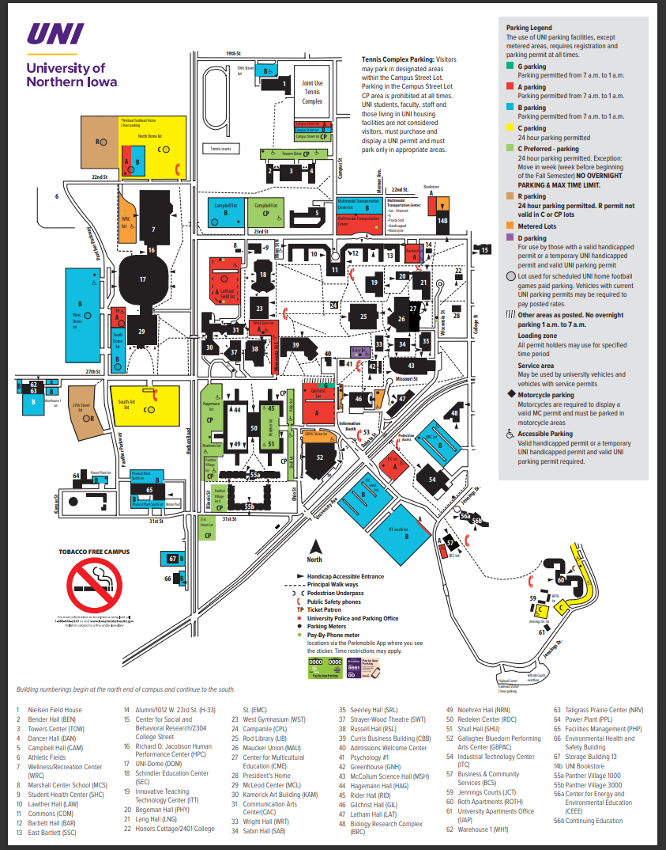
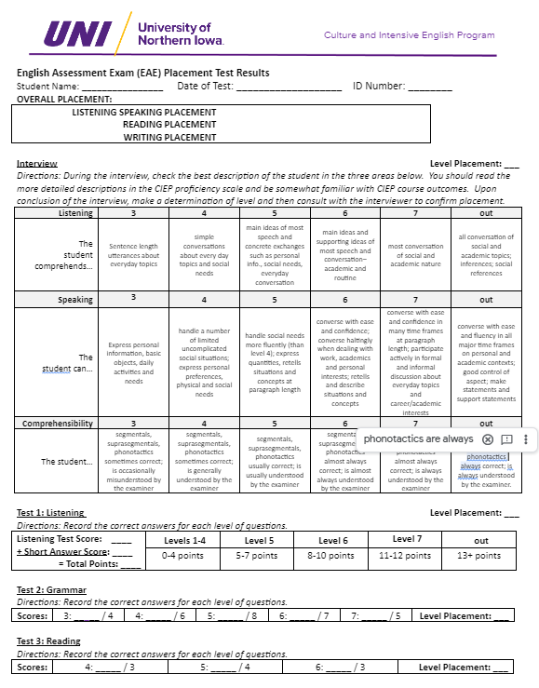
Appendix A-2 - English Placement Test Results

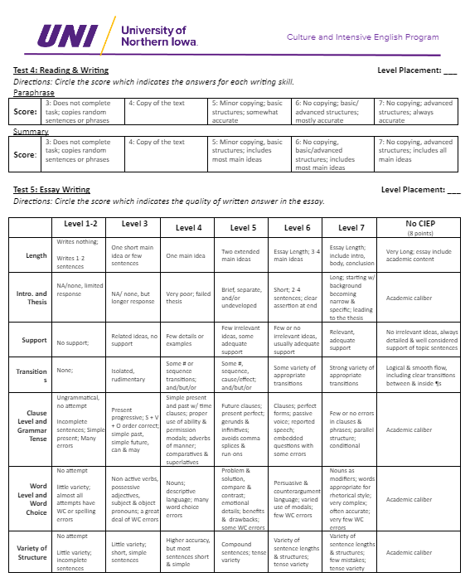

Formal Student Grievance Form
UNI-CIEP

STUDENT HANDBOOK: APPENDIX A-3

Student Information STAFF HANDBOOK: APPENDIX A-3
Name: Date: ______________________________
(MM/DD/YYYY)
UNI Email Address:

Instructions
The purpose of this form is to address a student grievance. This form should be used after consulting the staff member with whom a student has a grievance. If the outcome of that meeting does not resolve the grievance to the student's satisfaction, then the student needs to complete and sign a Formal Student Grievance Form and submit it to the CIEP Director through the CIEP administrative staff, in 3025 Bartlett Hall. The CIEP Director will review this form, as well as any attached documents, and may request a meeting with the student in order to understand the grievance fully.
Please know the student may always request a meeting with the CIEP Director.

The student will receive a decision within 10 days of submitting this form, unless more time is needed to address the grievance sufficiently.

Please describe the grievance as thoroughly as possible in English. However, if you are in Levels B, 2, or 3, you may use your primary or first language.

Student Signature:
Print
Reset Form

For Office Use Only. Received by: (initials) Date / /
Meeting requested/required? Yes No
*
Meeting with: Date: / / Time:
File Path: T:\Documents\Office Admin\Handbooks\Student Handbooks\CIEP Student Handbook\Student Handbook Appendices\Appendix A-3 -
Formal Student Grievance Form.pdf
Make copy for student, original to student file, record in spreadsheet

Student Requests and Concerns
Student Form

STUDENT HANDBOOK: APPENDIX A-4
STAFF HANDBOOK: APPENDIX A-2

Student Information
Name: Date: _________________________________
(MM/DD/YYYY)

UNI Email Address:

Instructions
Please describe your request or concern as thoroughly as possible in English. However, if you are in Levels B, 2, or 3, you may use your primary or first language. Once received, the form will be given to the appropriate staff member. That staff member will review the form and any attached documents and decide if a meeting is needed to address the request or concern. Please know you may always request to meet with the CIEP Director, Academic Support Coordinator, Promotions and Admissions Specialist, or Student Services Coordinator, and a meeting will be arranged.

You will receive a decision within 10 days of submitting this form, unless more time is needed to resolve the concern
sufficiently or fulfill the request.

Student Signature:
Print
Reset Form

For Office Use Only. Received by: (initials) Date / /

Academic |  Grades (general) |  | Services |  Housing |  | Admissions |  Scholarships |  | Director |  Schedule Change: Level/Teacher/Section
 |  Teacher (general) |  |  |  Classmates* |  |  |  Applications |  |  |  Probation/ Dismissal*
 |  Classroom Behavior* |  |  |  Transfer* |  |  |  I-20 Extension |  |  |  Withdrawal/ Return Home*
* Meeting requested/required?  Yes  No
Meeting with: Date: / / Time:
File Path: T:\Documents\Office Admin\Handbooks\Student Handbooks\CIEP Student Handbook\Student Handbook Appendices\Appendix A-4
- Student Requests and Concerns Form.pdf

Make copy for student, original to student file, copy to Requests & Concern file

CIEP STUDENT HANDBOOK APPENDIX B-1

CIEP Proficiency Scale
CIEP Level | CIEP Proficiency Indicators
CIEP I  IELTS – 0-3  TOEFL – 0-30  CEFR – A1-A2  Duolingo – <60  TOEFL PBT – 0-393 | Students completing CIEP I will be able to… Write unified paragraphs of 8-10 simple and compound sentences organized around a unified topic; produce original sentences using grammar structures with simple present/progressive tenses with SVO sentence order; Wh- questions with Be, simple past of “to be” and regular verbs; note important concepts in short reading and listening tasks; retell events from personal writing, reading and listening tasks; speak about simple, everyday topics with intelligible consonant, and short and long vowel sounds; apply basic language functions in unscripted conversation and oral presentation; read and understand main ideas and details of short, simple readings.
CIEP II  IELTS – 3-3.5  TOEFL – 30 -42  CEFR – A2 / B1  Duolingo – 60-70  TOEFL PBT – 397-460 | Students completing CIEP II will be able to… Write unified paragraphs of 10-13 simple and compound sentences in several rhetorical styles with topic and concluding sentences; produce original sentences with simple past and future; modals; count vs noncount nouns, Wh- questions, adverbs of manner; superlative; note important concepts in short reading, writing and listening tasks; discriminate between true/false and fact/opinion statements; express opinions and ideas about a conversation, a talk or written text; apply a variety of speaking and discussion with basic language functions in unscripted conversations and oral presentations; speak intelligibly with proper consonant and vowel sounds, word stress, and reductions; understand short speech in routine social situations and express basic needs; demonstrate proficiency in unscripted academic public speaking; read and understand modified texts in relation to academic topics.
CIEP III  IELTS – 3.5-4  TOEFL – 42 -60  CEFR – B1  Duolingo – 65-85  TOEFL PBT – 437-493 | Students completing CIEP III will be able to… Write unified paragraphs of 14-17 simple and compound sentences in several rhetorical styles with topic and concluding sentences; produce original sentences using simple past, present, future; present and past progressive, time clauses, present perfect/progressive, nouns: quantifiers and articles, gerunds/infinitives, modals, adverbs, adjective order, reflexive and reciprocal pronouns, and coordinating conjunctions; critically analyze and interpret main ideas from paragraphs, articles, lectures, talks and conversations; note important concepts to create or complete lecture/text notes; summarize and paraphrase main ideas, supporting details and conclusions of a text, talk or conversation; identify support of an author’s or speaker’s opinion; identify lecture language to recognize lecture content and organization; express opinions in relation to a conversation, talk or written text; apply a variety of speaking and oral presentation techniques; speak intelligibly with clear consonant and vowel sounds, word stress, sentence stress and reductions; converse in short and slow speech on general topics and usually be understood such as expressing basic needs, daily activities, and preferences; demonstrate proficiency in unscripted academic public speaking in a 3-5-minute presentation; read and understand moderately complex multi-page texts.
CIEP IV  IELTS – 4-5  TOEFL – 53-72  CEFR – B2  Duolingo – 80-95  TOEFL PBT – 477-530 | Students completing CIEP IV will be able to… Write unified multi-paragraph essays with simple and compound sentences and several rhetorical styles; these have a funnel introduction, thesis, hook, topic sentences, concluding sentence, effective transitions, and solid details and examples; produce original sentences using perfect tenses, reported speech, passive, indirect speech, embedded questions, adjective clauses, phrasal verbs, and modals; compile appropriate, research material related to the assignment using vetted library resources; paraphrase main ideas, supporting details and conclusions from a text, lecture or talk; relate class topics to personal experience; integrate ideas and concepts from a variety of sources; take and revise lecture notes, e.g., identifying main and supporting ideas of a 7- to 10-minute authentic lecture; participate effectively in academic small group discussions using negotiating, seeking and giving help and clarification, and discussing class topics; demonstrate proficiency in unscripted academic public speaking in a 4- to 6-minute presentation; read and understand slightly adapted and academic texts.
CIEP V  IELTS – 5.5-6.0  TOEFL – 65-78  CEFR – B2-C1  Duolingo – 85-99  TOEFL PBT – 513-547 | Students completing CIEP V will be able to… Write unified multi-paragraph essays logically divided paragraphs, simple and compound sentences and using logical division, comparison/contrast, argumentation or cause/effect using a funnel introduction, thesis, hook, topic sentences, concluding sentence, effective transitions, details and examples; write longer paragraphs of more than 10 complex, compound and simple sentences; show mastery of sentences with perfect tenses, reported speech, passive voice, indirect speech, noun clauses with embedded questions, adjective clauses, so, too, neither etc.., phrasal verbs, and modals; compile appropriate, research material using vetted library resources integrating ideas and concepts from those sources; cite outside sources while avoiding plagiarizing by using accepted citations conventions with in-text citations and a list of references; relate topics from texts, lectures, talks and research to personal experience; take and revise lecture notes: identifying main ideas, supporting sentences and details, and conclusion of a 10-minute or longer authentic lecture; participate effectively in discussion using negotiating, seeking and giving help and clarification, and discussing class topics; demonstrate proficiency in unscripted academic public speaking in a 5-7-minute presentation of research essay findings; converse with ease on personal and some academic topics at a general level; read and understand unadapted academic literature.

Guidelines for In-Class Behavior and Academic Integrity UNI CIEP
STUDENT HANDBOOK: APPENDIX B-2

Dear: Date:
It has come to my attention that your behavior in class has been disruptive and is a violation of respect for the teacher and other members of the class. A description of this behavior follows:

The UNI Student Conduct Code states that this type of behavior is a violation of respect for other individuals in the class, more specifically, Article II B.2 states that the following behavior is a violation of respect:
“Disruption or obstruction of teaching, research, administration, disciplinary proceedings, other University activities, including its public service functions on or off campus, or of other authorized non-University activities when the conduct occurs on University premises.”
Therefore, I am meeting you to talk about your behavior in class. Also, I think it is important for you to understand what behavior is expected from students in class. The guidelines listed below have been created by our staff, and I ask that you read them with me, understand their meaning, and agree to follow them. If you agree to follow them, please sign below. A copy will be given to you and your teachers. The original will stay in the CIEP office.

General Guidelines for In-Class Behavior of CIEP Students

- I will come to class on time.
- I will come to class prepared; I will read the assignments before class and I will do all my homework before class.
- If I need help, I will ask questions that deal with the lesson.
- I will be respectful of my classmates; I will listen to what they have to say.
- I will be patient with my classmates; I will give them a chance to answer questions on their own.
- I will participate in group activities by contributing positively to my group; this is where I will provide my classmates with answers to the exercises.
- I will listen to my instructor’s directions and follow them to the best of my ability.
- I will turn in my homework the day it is due.
- I will talk to my teacher about the assignments; if I miss one, I will turn it in as soon as possible.
- I will take breaks only during break time.
- I will use a cell phone to answer phone calls before or after my classes start.
- If I need help and I think it is necessary, I will talk to my teacher outside of class or to the CIEP Director.

UNI Student Policies on Academic Ethics (www.uni.edu/policies/301) states:
“Cheating of any kind on examinations and/or plagiarism of papers or projects is strictly prohibited.”

General Guidelines about Academic Integrity and CIEP Students
  - I will not obtain test papers or test answers from “friends,” internet or other sources.
  - I will not look at or copy from other students’ papers or work during a test or secretly communicate with others during a test to obtain or provide answers.
  - I will not present others’ work or ideas as my own without proper citation. Some sources of ideas include journal articles, book chapters, papers written by friends, and websites. If I do present ideas from outside sources, I will be sure to cite the ideas in my work.
  - I will not make up quotations and supply false citations.
  - I will supply quotation marks where appropriate.
  - I will not submit a single essay paper to more than one class without making the teachers in both classes aware of my action.

I agree that these general guidelines for CIEP student are important, and I will do my best to follow them.

Student Signature Date CIEP Staff Member Signature

For Office Use Only. Received by: (initials) Date / /
Student was presented form and declined to sign. Staff initials Date / /
File Path: T:\Documents\Office Admin\Handbooks\Student Handbooks\CIEP Student Handbook\Student Handbook Appendices\Appendix B-2 - Guidelines for In Class Behavior and Academic Integrity.pdf
Original copy to student file; make copy for student.

Notice of Plagiarism/Cheating
UNI CIEP

STUDENT HANDBOOK: APPENDIX B-3
Presenting someone else’s work as your own in an assignment without proper citation of the source is an act of plagiarism. Plagiarism can occur on any
written work or oral presentation related to your evaluation for a grade. Likewise, using outside help during a test or quiz or other evaluation without the consent of the teacher is an act of cheating. Plagiarism and cheating are acts of academic dishonesty and serious offenses in the U.S. academic environment. Please refer to the CIEP Student Handbook for more descriptions of these acts. Below is the description of your act of plagiarism or cheating along with the consequences.
Name of Student: Today’s date:

Class: Sp 1 Sp 2 Summer Fall 1 Fall 2
Year:
Description of assignment or activity:

Description of plagiarism or cheating committed by the student (include date of incidence) and action taken by the teacher (for each act, a typed description and copy of student’s work may be attached):

Teachers discuss plagiarism and cheating in class and provide warnings to students. If you are found to commit plagiarism or an act of cheating, you will be penalized in the following ways depending on the circumstances. Teacher marks below the corresponding type below:

Student committed a minor act of plagiarism or cheating in his/her work for a class. Minor acts include: copying a few lines of text without citing source, glancing at neighbor’s paper, whispering to others, and signaling others during an exam. These can result in a warning and/or meeting with the teacher.
◻

Student committed a minor act of plagiarism or cheating a second time in his/her work or exam for a class OR committed a serious act of plagiarism or cheating. Serious acts include: copying or purchasing an essay or other assignment and presenting it as your own, obtaining and using unauthorized materials (paper, electronic) or help (verbal) during an exam, or obtaining extensive help from classmates or non-classmates for an exam. These can result in a failing grade for the related assignment or exam.
◻

Student committed a minor act of plagiarism or cheating a third time in his/her work for a class OR committed a very serious act of plagiarism or cheating. Very serious acts include: organizing others to cheat or plagiarize, or providing copies of exams, essays or test materials to others. These can result in a failing grade for the class or expulsion from CIEP.
◻

Instructor signature: Instructor’s printed name:

Students signature: Student's printed name:

For Director Use Only. Received by: (initials) Date / /
File Path: T:\Documents\Office Admin\Handbooks\Student Handbooks\CIEP Student Handbook\Student Handbook Appendices\Appendix B-3 - Notice of Plagiarism Cheating.pdf

CIEP STUDENT HANDBOOK APPENDIX B-4
For Office Use Only. Received by: (initials) Date / /
Student was presented form and declined to sign. Staff initials Date / /
File Path: T:\Documents\Office Admin\Handbooks\Student Handbooks\CIEP Student Handbook\Student Handbook Appendices/Appendix B-4 – Notice of Academic Probation.pdf
Original copy to student file; make copy for student.

Notice of Academic Probation in the Culture and Intensive English Program

Student: Session:

The probation policies regarding Attendance, Performance, and Repeating a class are outlined in the CIEP Student Handbook on pages 18 and 19 (found online at http://www.uni.edu/ciep/students/handbook). Outlined below are the details of this student’s probation status.
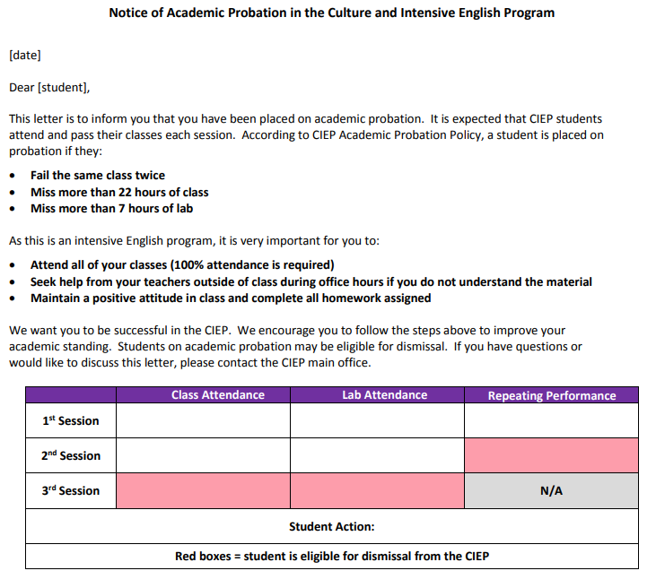

Student Handbook Appendix B-5

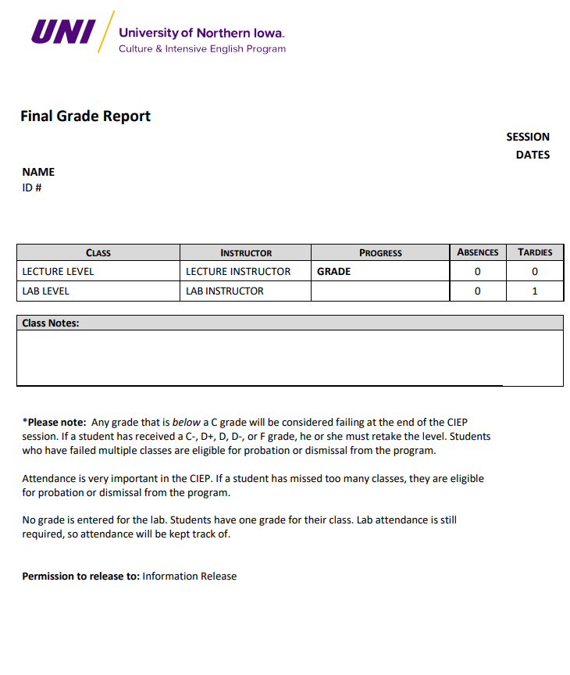

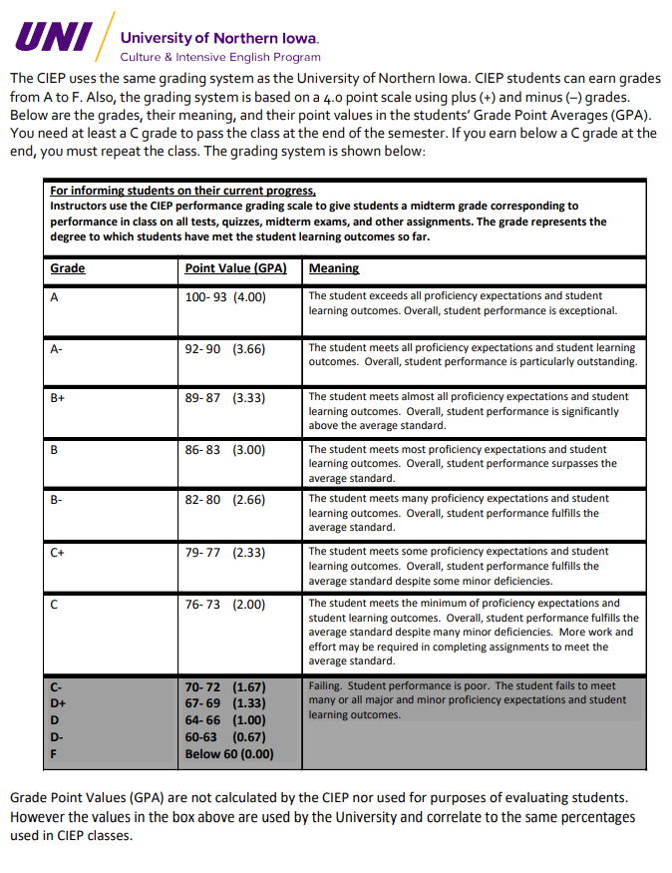

Appendix B-6 - CIEP Grading Scales

CIEP Grading Scale
 |  | For advancement to the next level or exit from the  program, instructors use the CIEP grading scale to give students a final grade corresponding to performance in class on all tests, quizzes, midterm exams, final exams and other assignments. The grade represents the degree to which students have met all the student learning outcomes. | For individual class assignments, instructors use the CIEP grading scale to give students a grade corresponding to what degree a student has met the specific student learning outcomes addressed in a particular assignment or evaluation.
A | 100-93 | The student exceeds all proficiency expectations and student learning outcomes. Overall, student performance is exceptional. The student passes to the next level. | The student exceeds all proficiency expectations and student learning outcomes. Overall, student performance is exceptional.
A- | 92-90 | The student meets all proficiency expectations and student learning outcomes. Overall, student performance is particularly outstanding. The student passes to the next level. | The student meets all proficiency expectations and learning outcomes. Overall, student performance is particularly outstanding.
B+ | 89-87 | The student meets almost all proficiency expectations and student learning outcomes. Overall, student performance is significantly above the average standard. The student passes to the next level. | The student meets almost all proficiency expectations and student learning outcomes. Overall, student performance is significantly above the average standard.
B | 86-83 | The student meets most proficiency expectations and student learning outcomes. Overall, student performance surpasses the average standard. The student passes to the next level. | The student meets most proficiency expectations and student learning outcomes. Overall, student performance surpasses the average standard.
B- | 82-80 | The student meets many proficiency expectations and student learning outcomes. Overall, student performance fulfills the average standard. The student passes to the next level. | The student meets many proficiency expectations and student learning outcomes. Overall, student performance fulfills the average standard.
C+ | 79-77 | The student meets some proficiency expectations and student learning outcomes. Overall, student performance fulfills the average standard despite some minor deficiencies. The student passes to the next level. | The student meets some proficiency expectations and student learning outcomes. Overall, student performance fulfills the average standard despite some minor deficiencies.
C | 76-73 | The student meets the minimum of proficiency expectations and student learning outcomes Overall, student performance fulfills the average standard despite many minor deficiencies. More work and effort may be required in completing assignments to meet the average standard. The student passes to the next level. | The student meets the minimum of proficiency expectations and student learning outcomes. Overall, student performance fulfills the average standard despite many minor deficiencies. More work and effort may be required in completing assignments to meet the average standard.
C- | 72-70 | Failing. Student performance is poor. The student fails to meet many or all major and minor proficiency expectations and student learning outcomes. The student does not meet the minimum standard for promotion to the next level. The student must continue in the same level. | Failing. Student performance is poor. The student fails to meet many or all major and minor proficiency expectations and student learning outcomes. The student does not meet the minimum standard and shows a great need for tutoring and help in completing work satisfactorily.
D+ | 69-67
D | 66-64
D- | 63-60
F Be | low 60

SEVIS Transfer-In Release Form

SEVIS School Code: OMA214F00208000
TO THE STUDENT: CIEP STUDENT HANDBOOK APPENDIX C-1

To process your request for an I-20 form, we must receive a status report from your current school’s International Student Advisor. Please complete the top section of the form, then give or mail the form to your current advisor to be completed.
I give permission for the information requested below to be sent to the Culture & Intensive English Program (CIEP) at the University of Northern Iowa.

Last Name (Family) First Middle

_
Signature Student ID # Date
○
○
○
○

I intend to transfer to the CIEP in: August October January March June Year: __________
○

Dear International Student Advisor:
The student named above has applied for transfer admission to the CIEP. Your assistance is requested in determining the student’s eligibility to transfer. Please supply the following information
- Student’s SEVIS #:
- Dates of last enrollment at your institution: From to
- Is the student eligible to continue at your institution? If not, please explain.
Yes ○ No ○
- Has the student met all financial obligations to your institution? Yes ○ No ○
- According to your knowledge, is the student currently in status with DHS? (If not please explain).

Yes No _________________________________________________________
- Was the student’s attendance and performance satisfactory? Yes ○ No ○
- Any authorized reduction in the student’s course load (i.e. medical, academic difficulties):

- SEVIS release date of student:
- We would appreciate any other information, which you feel would be helpful. Thank you.

Transfer Out Institution:

PDSO/DSO Name (please print): Phone:

Email: Fax:

PDSO/DSO Signature: Date:

Thank you for your assistance. If you have any questions, please contact Edyta Cichon.

Edyta Cichon, Immigration & Advising Coordinator
113 Maucker Union, Cedar Falls, IA 50614-0511
Ph: (319) 273-6422 Fax: (319) 273-3333
Edyta.cichon@uni.edu

Release of Information
UNI CIEP

STUDENT HANDBOOK: APPENDIX C-2

UNI Policies and Procedures: 3.11 Student Records
In order to follow the Family Educational Rights and Privacy Act of 1974 (FERPA), the Culture & Intensive English Program (CIEP) will not share any student’s information with anyone that is not a university employee with a legitimate reason to have the information without the student’s permission. The CIEP will not share a student’s information with another student, a family member, a friend, or any third-party organization without the written consent to share it. If a student wants another person or organization to have access to their CIEP academic information including registration, courses, academic performance, and grades, the student must complete and sign this form. By signing this form, the student gives CIEP permission to release information to the individuals and organizations listed. For more information, please refer to UNI’s Policies and Procedures: 3.11 Student Records at http://www.uni.edu/ policies/311 or ask any CIEP staff member.

Release of Information for Individuals
Name Relation to Student

Release of Information for Sponsors and Organizations
Sponsor or Organization Contact Person

I give permission to the individuals and organizations listed to receive my CIEP academic information on request for academic, financial, or employment purposes as long as I am enrolled in the CIEP.

Student’s name (print):

Student’s name (signature):

Date (month/day/year) : / /

For Office Use Only. Received by: (initials) Date / /
Student was presented form and declined to sign. Staff initials Date / /
File Path: T:\Documents\Office Admin\Handbooks\Student Handbooks\CIEP Student Handbook\Student Handbook Appendices
Record in Smartsheet, original copy to student file

Class/Teacher Evaluation Form
UNI CIEP

STUDENT HANDBOOK: APPENDIX C-3

Session Info
Class: ___________________ Session: _________________ Instructor: _______________________________

Instructions

Please fill in one bubble for each answer. Do not write your name on this paper. Your response will be typed by the CIEP office staff. Your teacher will not receive the results of this survey until after they have submitted grades.

Questions about the Student | Always | Frequently | Sometimes | Occasionally |  | Never
1. I came to this class… | ○ | ○ | ○ | ○ |  | ○
2. I did homework… | ○ | ○ | ○ | ○ |  | ○
Questions about the Teacher Strongly No Strongly
Agree |  | Agree | Opinion | Disagree | Disagree
3. The teacher was prepared. ○ |  | ○ | ○ | ○ | ○
4. The teacher used class time well. ○ |  | ○ | ○ | ○ | ○
5. The teacher encouraged questions. ○ |  | ○ | ○ | ○ | ○
6. I learned important academic skills from CIEP. ○ |  | ○ | ○ | ○ | ○
7. I knew what the teacher wanted. ○ |  | ○ | ○ | ○ | ○
8. I could understand the teacher. ○ |  | ○ | ○ | ○ | ○
9. I would take another class with this teacher. ○ |  | ○ | ○ | ○ | ○
Questions about the Class Strongly |  |  | No |  | Strongly
Agree |  | Agree | Opinion | Disagree | Disagree
10. The homework helped me. ○ |  | ○ | ○ | ○ | ○
11. This class helped me. ○ |  | ○ | ○ | ○ | ○
12. The class activities were interesting. ○ |  | ○ | ○ | ○ | ○
13. I was comfortable with my classmates. ○ |  | ○ | ○ | ○ | ○
14. I would suggest this class to others. ○ |  | ○ | ○ | ○ | ○
Questions about the Books Strongly |  |  | No |  | Strongly
Agree |  | Agree | Opinion | Disagree | Disagree
15. The books are helpful. ○ |  | ○ | ○ | ○ | ○

Comments: Please write any comments about your experience in this class below.

Print Form
Reset Form

Notification of Absence Form for Students in CIEP

STUDENT HANDBOOK: APPENDIX D-1
Dear Student:

This form is for students planning to return to CIEP after being away. Therefore, if you plan to be away from the CIEP for at least one session, please complete this form.

Please understand that UNI policy offers you ONE session away from studies; however, you must have studied for FOUR consecutive sessions in CIEP or TWO semesters at UNI. Of course, you may leave the university at any time for any reason, but you may have to get a new I-20 and/or visa to return. Knowing your plans, helps us keep your immigration record in good status.

Before you leave, please answer the questions below and give to the office staff in Bartlett 3025.

Your name

Your address in U.S.

Your home country address

Your e-mail

Your plan to return (when)

Your reason for leaving vacation travel

Other (please explain)

Your I-20 record SEVIS number

Signature Date
Print

For Office Use Only. Received by: (initials) Date / / Student was presented form and declined to sign. Staff initials Date / / File Path: T:\Documents\Office Admin\Handbooks\Student Handbooks\CIEP Student Handbook
\Student Handbook Appendices\D-1 - Notification of Absence Form.pdf Original copy to student file; make copy for student.

